Beyond Fresh Fruit Bunch Aggregation: A Framework for Koperasi Desa/Kelurahan Merah Putih (Indonesia’s Village Cooperatives) in Advancing Oil Palm Smallholder Welfare in Indonesia

Loso Judijanto¹

IPOSS Jakarta, Indonesia¹

Email: losojudijantobumn@gmail.com

Entered : August 7, 2026 Revised : August 12, 2026
Accepted : August 20,2026 Published : August 25, 2026

ABSTRACT

Indonesia's Koperasi Desa/Kelurahan Merah Putih (KDKMP) initiative creates a new institutional opportunity to strengthen village economies, including in regions dominated by independent and scheme oil palm smallholders. Yet cooperative formation, physical infrastructure, and subsidised financing do not automatically improve member welfare. This qualitative literature review synthesises recent evidence on agricultural cooperatives, oil palm smallholders, collective action, rural finance, replanting, certification, and cooperative governance to identify the roles KDKMP should perform and the conditions required for those roles to generate durable welfare gains. The review finds that KDKMP should move beyond a narrow fresh fruit bunch aggregation model, integrating transparent collective marketing, verified inputs and extension, savings and credit, replanting and legality support, group certification and traceability, and carefully staged local value addition. These functions can raise net income, stabilise cash flow, and strengthen bargaining power only when supported by genuine member ownership, professional management, adequate working capital, auditable digital records, and safeguards against elite capture and excessive debt. The article proposes a four-stage maturity model and a balanced performance dashboard that prioritise member-level outcomes over the number of cooperative entities, buildings, or business units. The central policy implication is that KDKMP should be governed as a member-owned rural economic platform whose expansion is conditional on demonstrated benefits, financial health, and institutional accountability.

Keywords: Agricultural cooperatives; Koperasi Merah Putih; rural welfare; collective action; smallholder replanting; sustainable palm oil

INTRODUCTION

Oil palm is deeply embedded in the economy of rural Indonesia. For many farm households, it provides regular cash income, supports asset accumulation, and links remote villages to transport, trade, financial, and service networks. Evidence from the Indonesian small-farm sector shows that oil palm cultivation can improve household welfare and living standards, but it can also increase exposure to commodity price risk and reproduce unequal access to land, capital, information, and organisational support (Mehraban et al., 2021; Mehraban et al., 2022). The policy problem is therefore not simply how to expand oil palm production, but how to ensure that a larger share of the value created by existing smallholder plantations is retained by farm households and translated into stable, inclusive, and sustainable welfare gains.
Independent and former scheme smallholders continue to face a dense bundle of constraints. These include low and variable yields, uneven access to quality seedlings and fertiliser, limited adoption of good agricultural practices, high transport costs, opaque weighing and grading, weak price information, insecure or incomplete land documentation, costly certification, and limited access to formal finance. Institutional research in Riau and Jambi emphasises that these constraints are mutually reinforcing: farmers with weak legality and organisation have difficulty obtaining credit, certification, technical support, and direct market access, while low productivity and irregular cash flow limit their capacity to invest in better practices (Dharmawan et al., 2021; Raharja et al., 2020; Watts et al., 2021). Recent field evidence further demonstrates that better agronomy can substantially raise yield and profit, but adoption requires coordinated extension, records, inputs, and incentives rather than one-off training alone (de Vos, Nurfalah, et al., 2023; Monzon et al., 2023; Sugianto et al., 2025).
Replanting has become an especially urgent challenge. A large share of smallholder palms is ageing, yet replanting requires capital, high-quality planting material, technical planning, and income support during the non-productive period. Farmers without clear land documents or organisational support often struggle to qualify for formal replanting assistance, while those relying on informal credit may face expensive or tied arrangements. Narrative and choice-experiment evidence identifies finance, knowledge, risk preferences, and access to quality inputs as central determinants of replanting participation (Hendrawan & Musshoff, 2024; Petri et al., 2023; Siregar et al., 2024). Replanting is thus not a purely agronomic intervention; it is a household livelihood transition that requires coordinated financial, technical, legal, and social support (Mulyasari et al., 2023).
Against this background, the Government of Indonesia launched the Koperasi Desa/Kelurahan Merah Putih initiative under Presidential Instruction No. 9 of 2025. The programme seeks to establish, develop, or revitalise approximately 80,000 village and urban-village cooperatives and explicitly allows business models to reflect local characteristics and existing economic institutions. Activities may include basic-goods outlets, savings and loans, warehouses, logistics, clinics, pharmacies, and other locally relevant enterprises. Subsequent regulation places emphasis on adaptive and sustainable business development, information systems, monitoring, and evaluation (Bachtiar & Abyan, n.d.). In oil palm villages, this policy space has encouraged expectations that KDKMP may aggregate fresh fruit bunches (FFB), organise transport, supply fertiliser, and eventually participate in local processing.
The reviewed material illustrates these emerging expectations. It reports proposed cooperative involvement in FFB collection, transport, strategic processing, and the circulation of income within villages. One reported case in Kelapa Sebatang, North Labuhanbatu, describes a cooperative purchasing community FFB and transporting it to a palm oil mill, while also identifying high rental costs and the need for working capital and a truck. Other reports indicate policy interest in cooperatives operating CPO facilities and other strategic businesses (Gideon, n.d.; InfoSumut, n.d.; Roshali, n.d.). These examples are useful as contextual signals, but they do not yet demonstrate changes in member net income, productivity, bargaining power, resilience, or the distribution of benefits. The analytical challenge is therefore to distinguish an activity list from a credible welfare mechanism.
This article asks: What roles should KDKMP perform in oil palm-producing villages to improve smallholder welfare; through what causal pathways can those roles generate benefits; and what institutional, managerial, financial, and regulatory prerequisites are required? It also examines major failure risks, including elite capture, delayed payment, debt-driven expansion, exclusion of vulnerable farmers, mission drift, and duplication of existing farmer institutions. The article argues that KDKMP can contribute to welfare only when it operates as a genuine member-owned rural economic platform, not merely as a new village intermediary, a government programme outlet, or an asset-holding body.
The article contributes an integrated role framework that connects cooperative theory with the specific production, market, legality, replanting, and sustainability problems of oil palm smallholders. It proposes a staged maturity model and a balanced performance dashboard that place member outcomes at the centre. The approach is deliberately conditional rather than promotional: cooperative membership and collective assets can be beneficial, but empirical studies also show that gains are heterogeneous, low-income households may be excluded, and broad membership without active participation can weaken performance (Blekking et al., 2021; Miller & Mullally, 2022; Zou & Wang, 2022).

LITERATURE REVIEW

Agricultural cooperatives are hybrid institutions that combine an enterprise function with a member-governance function. Members are simultaneously users, owners, suppliers, investors, and beneficiaries. This structure can align business activity with farmer needs, but it also creates governance complexity because members differ in farm size, liquidity, service use, risk tolerance, and expectations. Comparative research on cooperatives and farmer companies shows that ownership, control, benefit allocation, market specialisation, and external influence shape whether collective organisations remain accountable to farmers (Fernando et al., 2021). A useful starting principle for KDKMP is therefore that legal registration is not equivalent to cooperative identity; identity must be demonstrated through member control, economic participation, transparent benefit distribution, and credible accountability.

Collective action and transaction-cost theories explain why fragmented smallholders may benefit from organisation. Individually, farmers often lack the volume to negotiate with mills, the cash to purchase inputs in bulk, and the information to compare buyers or verify deductions. A cooperative can aggregate supply, coordinate transport, share fixed costs, and reduce search, bargaining, monitoring, and certification costs. Empirical studies across commodities show that cooperative membership can increase income, yields, market participation, technology adoption, and access to credit or extension, although effects vary by service quality and member characteristics (Ma, Zheng, & Yuan, 2022; Ma, Zheng, Zhu, et al., 2022; Seneerattanaprayul & Gan, 2021; Toiba et al., 2024; Yang et al., 2021; Zhang et al., 2020; Zheng et al., 2023). In Indonesia, positive welfare effects have also been found in dairy and capture fisheries, suggesting that stable market access, finance, information, and collective services can matter across sectors (Taniu et al., 2024; Toiba et al., 2024).

The literature simultaneously warns against assuming automatic inclusiveness. In Zambia, cooperative affiliation improved access to inputs and yields, but poorer households were less likely to join and therefore missed both programme benefits and cooperative-specific advantages (Blekking et al., 2021). Chinese evidence finds average income gains from cooperative membership, yet weaker or insignificant effects at the lowest income quantiles (Zou & Wang, 2022). Research in Nepal differentiates extensive inclusion, meaning broad and diverse membership, from intensive inclusion, meaning active participation in activities and decision-making; the latter is more strongly associated with performance (Miller & Mullally, 2022). For KDKMP, this distinction is fundamental. A large membership list may satisfy an administrative target while leaving poorer, remote, female, elderly, or less-connected farmers with little voice or service access.

Governance quality determines whether collective scale becomes bargaining power or merely creates another layer of intermediation. Social networks can encourage member participation in cooperative governance, but large and heterogeneous memberships can also increase conflict and distrust when information and rewards are uneven (Morfi et al., 2021; Sebhatu et al., 2020). Studies of smallholder cooperative performance emphasise basic management capability, adherence to member expectations, and clear rules, while qualitative comparisons show that heavy governmental influence can weaken autonomy and commercial focus (Fernando et al., 2021; Ishak et al., 2020). These findings are particularly relevant to a rapidly scaled national programme. Public support can lower start-up barriers, but top-down formation may produce passive membership, politically selected managers, or entities designed primarily to access subsidies (Geffersa, 2024; Jitmun et al., 2020; Mulyasari et al., 2023).

Oil palm cooperatives operate within a perishable and quality-sensitive value chain. FFB should be harvested at appropriate ripeness and transported quickly because delays reduce quality and extraction potential. Shorter harvest intervals and better field management can improve outcomes, but the benefits depend on coordinated labour, collection schedules, and reliable mill access (de Vos, Nurfalah, et al., 2023; Monzon et al., 2023). Collective marketing can therefore create value through volume, logistics, and quality control, yet it must be supported by transparent weighing, grading, deductions, and payment. Farmer-led collective trading is not necessarily inclusive when working capital is inadequate or when organisations select only commercially attractive members and volumes (Untari & Vellema, 2022).

Certification and traceability illustrate why an integrated institution is needed. Independent smallholders face barriers related to land legality, plantation registration, environmental documentation, farm records, audit costs, and group organisation. Certification groups that succeed often begin with stronger pre-existing institutions and clearer land rights, and they still depend heavily on external facilitators (Apriani et al., 2020; de Vos, Suwarno, et al., 2023; Watts et al., 2021). Certification may provide training, cost reductions, market access, or sustainability credits, but benefits are not guaranteed, and their distribution within groups matters. Recent choice evidence indicates that training and cash incentives can increase farmers' willingness to adopt certification, while risk attitudes shape uptake (Reich & Musshoff, 2025; Sukiyono et al., 2024). KDKMP can lower administrative costs through group systems, but it should not present certification as a simple label acquisition exercise.

A sustainable-livelihood perspective broadens the definition of welfare beyond gross FFB revenue. Welfare includes net income, income stability, savings, indebtedness, assets, nutrition, education, health, decision-making power, and resilience to shocks. Oil palm can support household welfare, but shocks such as price declines, pandemics, fire, flood, illness, and replanting can expose households to substantial vulnerability (Hammond et al., 2022; Irawan et al., 2022; Mehraban et al., 2021). Gender analysis also shows that apparently favourable labour-saving effects may coexist with reduced female control over farming and income (Mehraban et al., 2022). A welfare-oriented cooperative must therefore monitor who controls benefits, not only whether average revenue increases.

Digitalisation can support transparency and traceability when it is designed around member rights. A digital cooperative system can record verified membership, plot location, palm age, harvest volume, weighing, price, deductions, debt, input purchases, and patronage entitlements. Readiness research in a Riau oil palm cooperative highlights the need to integrate input, cultivation, marketing, and payment processes rather than digitising isolated activities (Falatehan et al., 2021). Evidence from smallholder digital services elsewhere shows that education, trust, connectivity, perceived usefulness, and institutional support influence participation (Abdulai et al., 2023; Geffersa, 2024; Jitmun et al., 2020). Digital systems should therefore supplement, not replace, accessible face-to-face services, and members should retain clear rights over their data.

Figure 1 summarises the causal logic derived from the literature. KDKMP's organisational capacity must first be converted into reliable member services; those services must then reduce identifiable production, market, finance, and legality constraints; and only after these intermediate effects occur should improved welfare be expected.

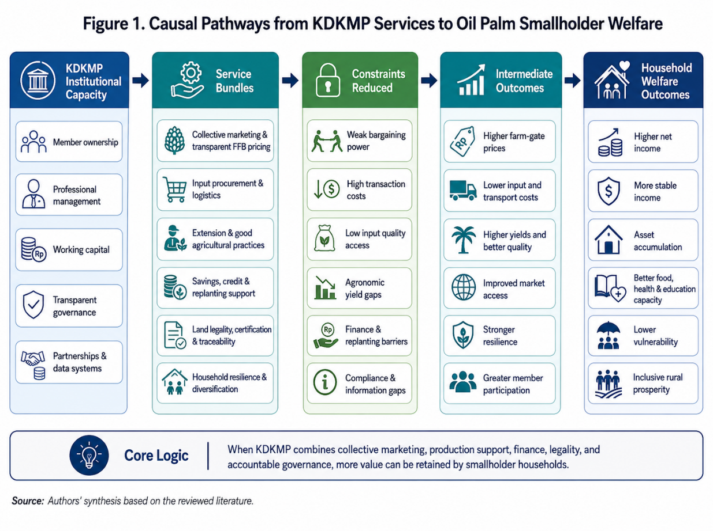

Figure 1. Causal Pathways from KDKMP Services to Oil Palm Smallholder Welfare

The figure also highlights why the same cooperative activity can produce different outcomes. FFB aggregation, for example, raises welfare only if it lowers net marketing costs, improves price or quality, shortens payment time, or returns surplus to members. Credit improves welfare only if it finances productive activity on affordable terms and does not create unmanageable deductions. The framework therefore treats member participation, monitoring, and adaptation as feedback loops rather than end-stage administrative requirements.

METHODS
This study uses a qualitative literature review, not a systematic literature review. The purpose is interpretive and integrative: to connect evidence from cooperative studies, oil palm smallholder research, rural finance, value-chain governance, replanting, certification, digitalisation, and gender analysis to develop a context-specific role framework for KDKMP. Qualitative evidence synthesis is appropriate when the research question concerns mechanisms, institutional conditions, meanings, and policy design rather than a pooled estimate of a single intervention effect (Flemming & Noyes, 2021; Johnston et al., 2020; Lubbe et al., 2020).
The review was conducted iteratively. Searches prioritised peer-reviewed journal articles published from 2020 onward using combinations of terms such as agricultural cooperative, farmer organisation, smallholder welfare, collective marketing, cooperative governance, oil palm smallholder, Indonesia, FFB, replanting, certification, traceability, rural finance, digital agriculture, gender, and elite capture. Literature was identified through major academic publisher platforms and citation tracing. Recent, reputable empirical and review articles were prioritised, while selected policy documents and the contextual material were used to describe the KDKMP initiative and emerging oil palm-related expectations. The approach did not use a PRISMA flow diagram, protocol registration, exhaustive database coverage, or meta-analysis, and it should not be interpreted as a systematic review.
Sources were selected purposively according to their contribution to one or more analytical domains: smallholder constraints; cooperative functions; welfare transmission mechanisms; governance and inclusion; replanting and finance; legality and certification; digitalisation and traceability; environmental practices; and implementation risks. The review also deliberately included evidence showing limited, unequal, or adverse outcomes. This negative-case logic reduces the risk of constructing a purely promotional account of cooperatives.
The analysis proceeded through thematic coding. First-order codes identified specific constraints and services, such as delayed payment, transport cost, fertiliser quality, land documentation, audit expense, or weak member participation. These codes were grouped into higher-order themes representing expected KDKMP roles and institutional prerequisites. The themes were then organised into a causal sequence linking cooperative capacity, services, intermediate outcomes, and household welfare. Finally, the synthesis was translated into a maturity model and performance dashboard.
The review has three limitations. First, KDKMP is a recent initiative, so direct longitudinal impact evaluations remain scarce. Second, oil palm villages differ in distance to mills, farmer typology, land legality, plantation age, existing organisations, and local political economy; recommendations cannot be applied mechanically. Third, evidence from other commodities and countries is used to illuminate cooperative mechanisms, but contextual transfer requires caution. Accordingly, the findings distinguish among policy expectations, evidence-supported roles, and the article's own institutional design proposals.

RESULTS AND DISCUSSION

The thematic synthesis identifies an integrated portfolio of expected roles. No single KDKMP needs to own every asset or deliver every service directly. The appropriate model is a platform that coordinates member demand, selects viable functions, contracts specialised partners, and gradually develops internal capacity. Figure 2 presents this integrated role architecture around the smallholder household.
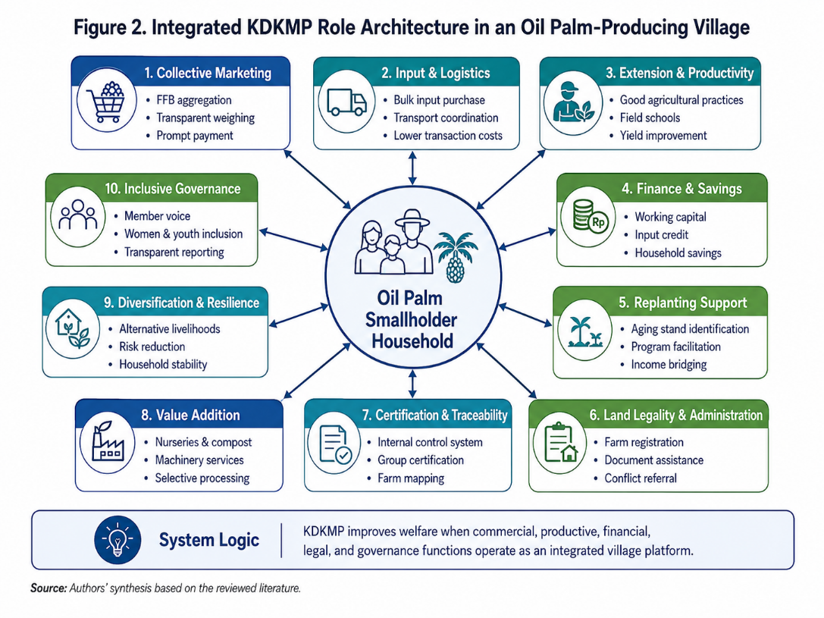
Figure 2. Integrated KDKMP Role Architecture in an Oil Palm-Producing Village

The central implication of Figure 2 is that cooperative services should be selected according to the binding constraints faced by members. In one village, transport and transparent weighing may produce the largest immediate gain; in another, replanting documentation, legality, or fertiliser access may be more important. Governance, data integrity, and viable partnerships form the foundation beneath every service domain. A cooperative that expands horizontally without strengthening these foundations risks becoming administratively complex but economically weak.

Transparent FFB aggregation and collective marketing. The most immediate role for KDKMP in many oil palm villages is to aggregate members' FFB and negotiate with buyers. Aggregation can increase bargaining volume, reduce per-unit transport cost, and create access to mills that would not transact efficiently with individual farmers. However, the cooperative should disclose the reference price, buyer price, weighing result, quality deduction, transport fee, service charge, debt deduction, and payment date for every transaction. Digital or printed receipts should be understandable to members. The service should be evaluated against the farmer's best available alternative, because simply replacing a private collector with a cooperative collector does not create welfare.
Prompt payment is essential. Many smallholders use frequent FFB income for food, schooling, health, labour, and debt repayment. A cooperative that waits for mill settlement before paying members may impose liquidity costs that farmers cannot bear. KDKMP therefore requires working capital, a revolving fund, or a prudently structured credit line. Surplus allocation should combine reserves with patronage-based returns linked to member transactions. Cooperative welfare effects emerge through better net prices, lower deductions, more reliable payment, and member claims on surplus, not from gross sales turnover alone (Seneerattanaprayul & Gan, 2021; Untari & Vellema, 2022; Zou & Wang, 2022).

Shared logistics and harvest coordination. The reviewed case from Kelapa Sebatang highlights the practical importance of transport ownership or reliable leasing. Yet purchasing a truck should follow a route, volume, utilisation, maintenance, driver, insurance, and cash-flow analysis. Underused trucks can become debt burdens, while poorly governed transport contracts create opportunities for related-party transactions. KDKMP can also coordinate collection schedules, calibrated mobile scales, harvest intervals, and delivery windows. Because FFB quality deteriorates with delay, logistics is a value-creation function rather than a secondary convenience (de Vos, Nurfalah, et al., 2023; dos Santos et al., 2020).

Affordable and verified inputs. Bulk procurement can lower the price of fertiliser, herbicides, tools, and planting material, but quality assurance is equally important. Counterfeit or inappropriate inputs can cause long-term yield losses. KDKMP should prequalify suppliers, publish procurement terms, maintain stock records, and provide agronomic guidance linked to farm needs. Input credit should be transparent, with clear interest or service charges, repayment schedules, and limits based on realistic farm cash flow. Evidence from Zambia and China shows that cooperative input access and technology adoption can improve yields and welfare, while also warning that better-off farmers may capture benefits if membership and credit conditions exclude poorer households (Blekking et al., 2021; Gava et al., 2021; Geffersa, 2024; Yang et al., 2021).

Extension, farm records, and productivity improvement. Smallholder yield gaps are not explained by one practice. Nutrient management, harvest interval, weed control, pruning, soil management, labour organisation, and planting material interact. KDKMP can organise farmer field schools, demonstration plots, soil and leaf analysis, service-provider contracts, and peer learning. It should maintain simple farm records that allow members to compare yield, costs, and profit before and after intervention. Empirical oil palm studies show that better management practices can raise yield and profit substantially, but benefits depend on adoption quality and local starting conditions (Monzon et al., 2023; Sugianto et al., 2025).

Savings, credit, and risk management. A welfare-oriented cooperative should distinguish among working-capital finance for the cooperative, productive credit for members, emergency credit, and long-term replanting finance. Combining these in one undifferentiated loan product obscures risk. Savings products can help households prepare for fertiliser purchases, school expenses, illness, or replanting. Credit decisions should be governed by written policy rather than political discretion, and loan deductions from FFB sales should be visible on every statement. Cooperative credit can support technology adoption and consumption smoothing, but it cannot compensate for an unviable farm or poorly designed investment (Seneerattanaprayul & Gan, 2021; Taniu et al., 2024).

Replanting facilitation. KDKMP can map palm age, identify priority plots, aggregate demand for certified seedlings, organise technical plans, assist programme applications, and coordinate contractors. The cooperative should also help households design an income bridge during the immature period through savings, intercropping where suitable, temporary employment, livestock, or diversified enterprises. Replanting support must recognise heterogeneity: a household with two hectares and no off-farm income faces a different transition from a household with multiple plots and salaried income. Literature on replanting repeatedly identifies knowledge, finance, land documentation, and income risk as interconnected barriers (Hendrawan & Musshoff, 2024; Petri et al., 2023; Siregar et al., 2024).

Land legality and administrative assistance. KDKMP can create a documentation desk to help members organise identity records, land evidence, plantation registration, tax documents, maps, and applications to competent agencies. It should not unilaterally certify ownership or legitimise disputed land. Instead, it should identify cases, explain requirements, and refer disputes to authorised institutions. This function has high welfare relevance because legality affects eligibility for credit, replanting support, certification, and market access. Studies of ISPO and RSPO readiness show that administrative complexity disproportionately disadvantages independent and historically unsupported smallholders (de Vos, Suwarno, et al., 2023; Dharmawan et al., 2021; Watts et al., 2021).

Group certification, traceability, and internal control. KDKMP can lower per-farmer costs by maintaining plot maps, member registries, harvest records, training logs, input records, and an internal control system. It can contract auditors or facilitators and negotiate with certified buyers. Yet certification should remain a means rather than an end. The cooperative must explain expected costs, market benefits, credit or premium distribution, and sanctions for non-compliance. Evidence indicates that certified groups often depend on facilitators and that financial benefits may be modest or unevenly distributed (Apriani et al., 2020; de Vos, Suwarno, et al., 2023; Innocenti & Oosterveer, 2020; Reich & Musshoff, 2025).

Digital transaction and member-data systems. A minimum system should allow members to verify each delivery, weight, quality result, price, deduction, loan balance, and payment status. More advanced systems can support geolocation, traceability, agronomic records, and service scheduling. Data governance must specify who can access, correct, share, or monetise member data. Paper alternatives and assisted access should remain available for members with limited digital literacy. Digitalisation should reduce information asymmetry rather than simply transfer administrative burdens to farmers (Abdulai et al., 2023; Falatehan et al., 2021).

Local value addition. Potential activities include nurseries, composting, biomass utilisation, machinery rental, repair services, transport, and participation in processing. However, CPO milling is capital-intensive, technically demanding, environmentally regulated, and dependent on a reliable catchment of FFB. A village cooperative should not assume that mill ownership automatically captures value. Feasibility must test supply volume, seasonality, extraction efficiency, waste treatment, energy, management competence, debt service, product marketing, and the opportunity cost of capital. Where scale is insufficient, several cooperatives can establish a secondary cooperative or joint enterprise while preserving transparent supply and benefit arrangements (Dalheimer et al., 2022; dos Santos et al., 2020).

Diversification and household resilience. KDKMP may support food crops, livestock, local processing, retail, or service enterprises when they complement rather than distract from the core member proposition. Diversification is particularly important during replanting and commodity shocks. The COVID-19 period demonstrated that both farm and off-farm income disruptions can affect oil palm households, while broader smallholder evidence shows that diversified livelihoods and assets support resilience (Hammond et al., 2022; Irawan et al., 2022). The cooperative should therefore assess household risk, not only plantation production.

Gender, youth, and vulnerable-member inclusion. Membership rules should recognise women as farmers, land users, workers, financial managers, and decision makers. Meeting times, information channels, training access, credit design, and leadership pathways can otherwise reproduce male dominance. Oil palm may reduce women's farm labour while also weakening their control over farm decisions and income, so welfare monitoring should include intra-household voice and benefit control (Geffersa, 2024; Jitmun et al., 2020; Mehraban et al., 2022; Qanti et al., 2022). Rural youth can contribute to mapping, digital records, machinery, logistics, accounting, extension, and downstream ventures, but participation should involve real career pathways rather than unpaid programme tasks.

Environmental stewardship. KDKMP can coordinate no-burning replanting, shared machinery, riparian protection, soil conservation, integrated pest management, and fire preparedness. It can also aggregate demand for environmental services and facilitate monitoring. Sustainability assessments of Indonesian smallholder oil palm indicate persistent weaknesses across environmental, institutional, and technological dimensions, while remote-sensing and multi-criteria tools offer possibilities for more practical farm-level assessment (Suardi et al., 2022; Sukiyono et al., 2024; Supriatna et al., 2024; Wong et al., 2023). Environmental services should be linked to productivity and risk reduction so that compliance is not perceived as an external burden alone.

A staged maturity model. Figure 3 proposes four stages: institutional readiness; basic commercial services; integrated farm and financial services; and value addition through federation or partnership. The model rejects the assumption that every new KDKMP should immediately operate multiple capital-intensive business units.

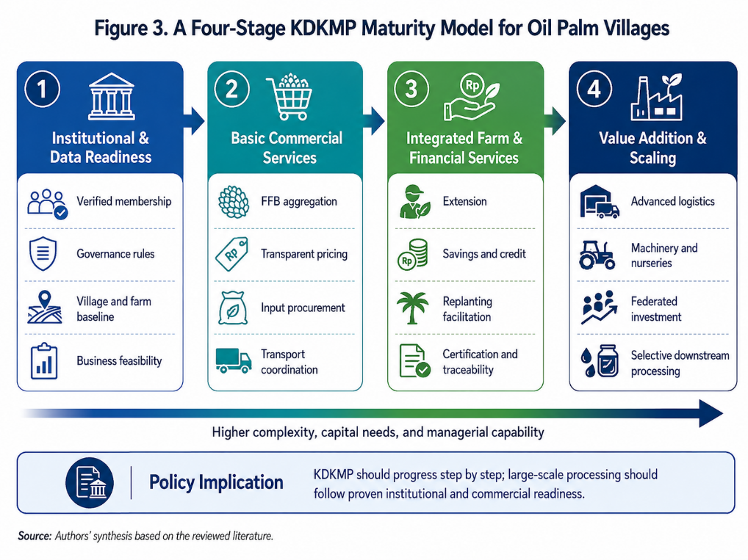
Figure 3. A Four-Stage KDKMP Maturity Model for Oil Palm Villages

Stage progression should be conditional. A cooperative should not advance to large borrowing or processing investment unless it has verified active membership, audited accounts, stable transaction volume, positive operating cash flow, adequate reserves, competent management, and evidence that earlier services increased member value. This sequencing protects members from debt-funded prestige projects and allows capabilities to develop through experience (Jitmun et al., 2020).
Genuine member ownership and professional management. The general meeting should approve strategy, elect and remove leaders, review audited reports, and decide surplus allocation. Boards should oversee rather than manage daily operations, while managers should be recruited for competence under written contracts and performance targets. Conflict-of-interest declarations are necessary for procurement, transport, construction, credit, and buyer contracts. Social networks can support participation, but transparent formal controls are needed when organisations grow (Morfi et al., 2021; Mulyasari et al., 2023; Sebhatu et al., 2020).
Financial accountability and working capital. KDKMP needs accounting that separates business units and identifies the source of profits and losses. Cash purchases of FFB, inventory, transport, credit, grants, and fixed assets should be recorded in auditable systems. Independent audits, periodic member reports, procurement thresholds, dual authorisation, inventory checks, and whistleblowing channels should be mandatory. The strongest member proposition can fail if the cooperative lacks liquidity to pay farmers or if funds are diverted to unrelated activities.
Partnership architecture. KDKMP should negotiate with multiple mills where feasible, establish clear quality and payment clauses, and avoid exclusive dependency unless a contract provides verifiable benefits. Partnerships with banks, BPDPKS-related programmes, plantation agencies, land offices, certifiers, universities, extension providers, and technology firms should specify responsibilities, data rights, cost sharing, and dispute procedures. Existing farmer groups, KUDs, associations, and BUMDes should be mapped before a new service is launched. The objective is institutional complementarity, not displacement.
Risk controls. Figure 4 pairs enabling conditions with specific safeguards. The figure emphasises that capacity and control must be designed together. Strong capital without transparent procurement can facilitate capture; strict rules without qualified staff can paralyse operations.

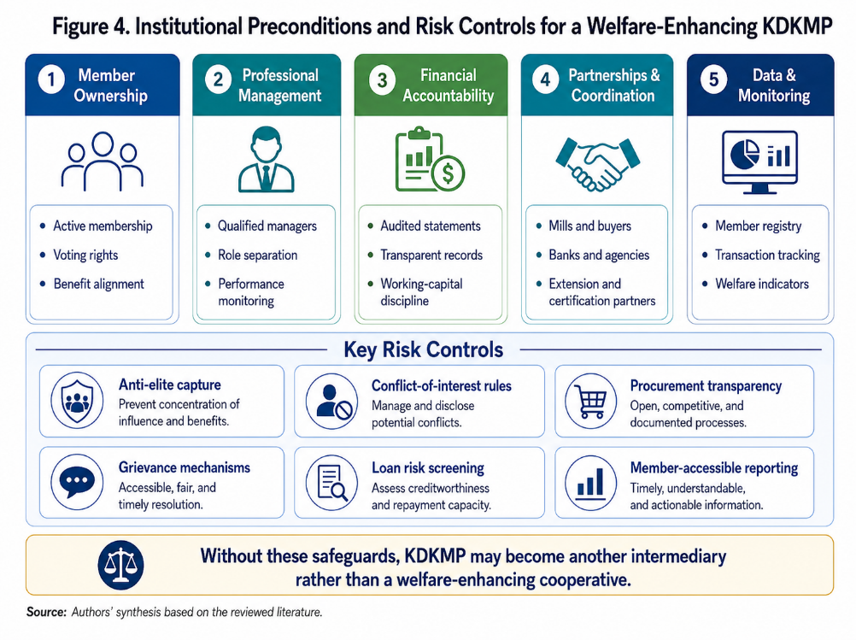
Figure 4. Institutional Preconditions and Risk Controls for a Welfare-Enhancing KDKMP

Four risks deserve particular attention. First, elite capture may concentrate leadership, credit, contracts, and information among connected households. Second, delayed payment can transfer liquidity risk from the cooperative to poorer farmers. Third, excessive debt can make members responsible for assets whose utilisation and returns were never independently tested. Fourth, mission drift can lead managers to prioritise turnover, non-member trade, or politically visible projects over member benefits. These risks should be addressed through public disclosure, independent feasibility review, debt-service limits, equitable service standards, grievance mechanisms, and regular member-benefit audits.

DISCUSSION AND ANALYSIS

The synthesis suggests that the most appropriate institutional concept for KDKMP is neither a simple collector nor a fully integrated conglomerate. It is a rural economic platform that coordinates services around member constraints and develops ownership selectively. This platform logic allows the cooperative to contract transport before buying a truck, use accredited agronomists before hiring a full technical department, or federate with neighbouring cooperatives before investing in processing. The key strategic question is not whether an activity sounds valuable, but whether KDKMP can deliver it more efficiently, transparently, and equitably than available alternatives.
The welfare transmission mechanism has four layers. The first is transaction improvement: lower search, procurement, transport, certification, and bargaining costs. The second is production improvement: better inputs, management practices, harvesting, and replanting. The third is risk reduction: savings, affordable finance, prompt payment, diversification, and more predictable contracts. The fourth is capability and voice: access to information, legal identity, records, leadership, data, and collective negotiation. Welfare gains are strongest when these layers reinforce each other. For example, farm records can improve extension, credit assessment, traceability, and bargaining simultaneously (dos Santos et al., 2020; Innocenti & Oosterveer, 2020).
This framework also clarifies why FFB aggregation is necessary but insufficient. A collector model addresses only one part of the marketing problem and may leave productivity, replanting, land legality, and household vulnerability unchanged. If the cooperative pays the same net price as existing collectors, uses opaque deductions, or delays payment, it may create no benefit. Conversely, even a modest aggregation operation can be transformative when it produces reliable transaction records, builds trust, creates working capital discipline, and becomes a platform for inputs and extension (dos Santos et al., 2020; Gava et al., 2021).
The KDKMP initiative creates a tension between rapid public mobilisation and cooperative autonomy. Government can provide legal facilitation, capital, infrastructure, training, and coordination, but authentic member ownership cannot be administratively declared. Comparative cooperative evidence shows that external support is often important, yet excessive governmental influence can produce passive members, distorted business choices, and organisations formed mainly to access benefits (Fernando et al., 2021; Sebhatu et al., 2020). Policy should therefore shift from formation targets toward consolidation targets: active-member ratios, transaction volumes, audited reporting, member satisfaction, and measurable welfare effects.
Business differentiation is equally important. Oil palm villages vary widely. Some are close to several mills and need transparent collective negotiation; others are remote and face severe transport costs. Former scheme farmers may have clearer land titles and stronger groups, while independent farmers may require intensive legality and organisation support. Villages with ageing palms need replanting services, whereas younger plantations may gain more from agronomy and market improvement. A uniform seven-unit or multipurpose template risks allocating capital to low-priority activities and overloading inexperienced management (Gava et al., 2021; Jelsma et al., 2024).
The inclusion-performance literature implies that KDKMP should pursue deep inclusion rather than symbolic inclusion. Membership should be open and fair, but services and governance must actively reach members with smaller farms, weaker literacy, limited transport, or less political influence. Intensive inclusion can be measured through meeting participation, service use, access to information, complaint resolution, and representation in committees. Special support may be needed for members who cannot meet standard volume, collateral, or documentation requirements, provided such support is transparent and financially sustainable (Blekking et al., 2021; Miller & Mullally, 2022).
A balanced performance system is needed because conventional enterprise indicators can conceal member harm. Turnover may rise while payment delays increase; assets may grow while debt service erodes patronage benefits; certified volume may expand while premiums are retained by management; and membership may increase while participation declines. Figure 5 proposes five dimensions: member welfare, farm performance, market performance, institutional quality, and sustainability.
The dashboard operationalises the article's central claim. Net farm income and income stability should be tracked alongside FFB yield, quality deductions, farm-gate price, payment time, meeting participation, audit quality, complaint resolution, legal documentation, and traceable volume. Disaggregation by farm size, gender, age, village location, and member status is essential. Expansion should occur only when member-level benefits, financial health, and governance indicators improve together.
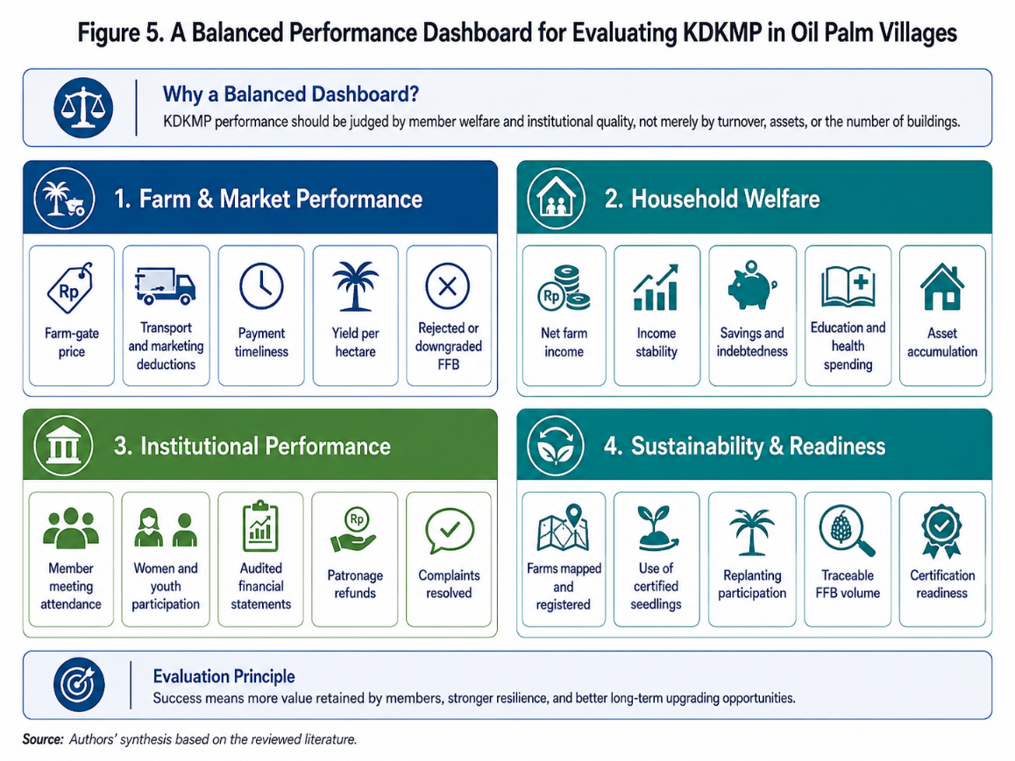
Figure 5. A Balanced Performance Dashboard for Evaluating KDKMP in Oil Palm Villages

Policy financing should therefore be milestone-based. Initial grants may support legal formation, member verification, training, basic systems, and feasibility studies. Working-capital facilities can be released when transaction contracts and controls are operational. Asset loans should require independent feasibility, minimum member equity, procurement transparency, insurance, and debt-service stress testing. High-capital projects should be evaluated at the federation or regional level rather than assumed to be appropriate for each village. This approach aligns public support with capability development and reduces moral hazard.
Monitoring should combine administrative data with member experience. Digital systems can provide transaction and financial indicators, while periodic member surveys can assess trust, perceived fairness, service accessibility, and household effects. Independent evaluation should compare outcomes with baseline conditions and suitable comparison villages. Because KDKMP is new, policy learning should be iterative: unsuccessful models should be modified or closed rather than protected for political reasons, and successful models should be scaled with attention to the local conditions that produced success.
The broader theoretical implication is that cooperative ownership is necessary but insufficient. Welfare depends on how ownership is translated into control, service quality, risk allocation, and surplus distribution. A cooperative can reproduce the same power asymmetries as private intermediation if members cannot verify transactions or influence decisions. Conversely, a professionally managed cooperative can remain authentically member-owned when governance rights are clear, information is accessible, and managers are accountable for measurable member outcomes (Jelsma et al., 2024).
Finally, the framework reframes local value addition. Value is not captured merely because an asset is located in the village or legally owned by a cooperative. Value is captured when the activity generates a sustainable surplus after operating costs, depreciation, finance costs, environmental compliance, and management risk, and when that surplus or service benefit reaches members. This distinction is especially important for mills, warehouses, and energy projects. Asset visibility should never substitute for member-value accounting.

CONCLUSIONS
KDKMP has the potential to strengthen oil palm smallholder welfare, but positive outcomes are conditional rather than automatic. The cooperative should move beyond the narrow role of FFB collector and integrate the functions that address the most binding constraints in each village: transparent marketing, prompt payment, logistics, verified inputs, extension, farm records, savings and credit, replanting facilitation, legality, certification, traceability, diversification, and environmental stewardship. These functions can raise net income, stabilise cash flow, improve productivity, and strengthen bargaining power when they are delivered as a coherent member service system.
The most important institutional requirement is the combination of genuine member ownership and professional commercial management. Members need meaningful voting rights, accessible information, transparent patronage benefits, and credible mechanisms to remove leaders. Managers need competence, clear authority, performance targets, and protection from day-to-day political interference. Adequate working capital is essential, especially for FFB purchasing, because delayed payment can erase the cooperative's welfare advantage for poorer households.
Policy should adopt a phased model. First, KDKMP should verify members, map farms and existing institutions, establish governance rules, and complete business diagnostics. Second, it should prioritise low-risk, high-impact services such as transparent weighing, collective transport, input procurement, extension, and administrative support. Third, it may integrate finance, replanting, certification, and digital traceability. Fourth, value-added investments should proceed only after governance, cash flow, supply, and management capacity are demonstrated, preferably through federation where scale is required.
Public financing and evaluation should be tied to member outcomes rather than entity counts or physical construction. Mandatory indicators should include net member income, payment time, yield, quality deductions, service use, active participation, audited accounts, complaint resolution, debt-service capacity, inclusion of women and vulnerable farmers, legalised plots, and traceable volume. Independent feasibility reviews, transparent procurement, conflict-of-interest rules, data protections, and grievance systems should be non-negotiable safeguards.
The policy objective is not to make every KDKMP large. It is to make each KDKMP useful, trusted, solvent, and accountable to its members. In oil palm villages, the decisive test is whether the cooperative increases the value retained by smallholder households and strengthens their resilience over the full plantation cycle, including replanting and market shocks. When judged by that standard, KDKMP can become a durable institutional bridge between small farms, modern value chains, public programmes, and locally anchored prosperity.

REFERENCE
Abdulai, A.-R., KC, K. B., & Fraser, E. (2023). What factors influence the likelihood of rural farmer participation in digital agricultural services? Experience from smallholder digitalization in Northern Ghana. Outlook on Agriculture, 52(1), 57–66. https://doi.org/10.1177/00307270221144641
Apriani, E., Kim, Y. S., Fisher, L. A., & Baral, H. (2020). Non-state certification of smallholders for sustainable palm oil in Sumatra, Indonesia. Land Use Policy, 99. https://doi.org/10.1016/j.landusepol.2020.105112
Bachtiar, R., & Abyan, D. (n.d.). Koperasi Merah Putih: A national strategy for inclusive growth. ARMA Law: ESG and Climate Change. Retrieved May 6, 2026, from https://www.arma-law.com/news-event/newsflash/koperasi-merah-putih-a-national-strategy-for-inclusive-growth
Blekking, J., Gatti, N., Waldman, K., Evans, T., & Baylis, K. (2021). The benefits and limitations of agricultural input cooperatives in Zambia. World Development, 146. https://doi.org/10.1016/j.worlddev.2021.105616
Dalheimer, B., Kubitza, C., & Brümmer, B. (2022). Technical efficiency and farmland expansion: Evidence from oil palm smallholders in Indonesia. American Journal of Agricultural Economics, 104(4), 1364–1387. https://doi.org/10.1111/ajae.12267
de Vos, R. E., Nurfalah, L., Tenorio, F. A., Lim, Y. L., Monzon, J. P., Donough, C. R., Sugianto, H., Dwiyahreni, A. A., Winarni, N. L., Mulani, N., Ramadhan, G., Imran, M. A., Tito, A. P., Sulistiawan, P., Khoirul, M., Farrasati, R., Pradiko, I., Grassini, P., & Slingerland, M. (2023). Shortening harvest interval, reaping benefits? A study on harvest practices in oil palm smallholder farming systems in Indonesia. Wageningen University & Research. https://edepot.wur.nl/632153
de Vos, R. E., Suwarno, A., Slingerland, M., van der Meer, P. J., & Lucey, J. M. (2023). Pre-certification conditions of independent oil palm smallholders in Indonesia. Assessing prospects for RSPO certification. Land Use Policy, 130. https://doi.org/10.1016/j.landusepol.2023.106660
Dharmawan, A. H., et al. (2021). The agrarian, structural and cultural constraints of smallholders' readiness for sustainability standards implementation: The case of Indonesian sustainable palm oil in East Kalimantan. Sustainability, 13(5), 2611. https://doi.org/10.3390/su13052611
dos Santos, L. P., Schmidt, C. M., & Mithöfer, D. (2020). Impact of collective action membership on the economic, social and environmental performance of fruit and vegetable farmers in Toledo, Brazil. Journal of Co-operative Organization and Management, 8(1). https://doi.org/10.1016/j.jcom.2020.100107
Falatehan, A. F., Syaukat, Y., Hariyadi, H., & Falatehan, S. F. (2021). Strategi kesiapan koperasi dalam digitalisasi perkebunan kelapa sawit rakyat. Jurnal Ilmu Pertanian Indonesia, 26(4), 537–545. https://doi.org/10.18343/jipi.26.4.537
Fernando, S., Garnevska, E., Ramilan, T., & Shadbolt, N. (2021). Organisational attributes of cooperatives and farmer companies. Journal of Co-operative Organization and Management, 9(1). https://doi.org/10.1016/j.jcom.2021.100132
Flemming, K., & Noyes, J. (2021). Qualitative evidence synthesis: Where are we at? International Journal of Qualitative Methods, 20. https://doi.org/10.1177/1609406921993276
Gava, O., Ardakani, Z., Delalić, A., Azzi, N., & Bartolini, F. (2021). Agricultural cooperatives contributing to the alleviation of rural poverty. The case of Konjic (Bosnia and Herzegovina). Journal of Rural Studies, 82, 328–339. https://doi.org/10.1016/j.jrurstud.2021.01.034
Geffersa, A. G. (2024). Agricultural cooperative membership and welfare of maize farmers in Ethiopia: Insights from panel data analysis. Annals of Public and Cooperative Economics, 95(4), 1223–1250. https://doi.org/10.1111/apce.12481
Gideon, A. (n.d.). Koperasi Desa Merah Putih bakal kelola pabrik minyak sawit hingga PLTS. Liputan6 Bisnis Ekonomi. Retrieved August 6, 2026, from https://www.liputan6.com/bisnis/read/8244596/koperasi-desa-merah-putih-bakal-kelola-pabrik-minyak-sawit-hingga-plts
Hammond, J., et al. (2022). Perceived effects of COVID-19 restrictions on smallholder farmers: Evidence from seven lower- and middle-income countries. Agricultural Systems, 198. https://doi.org/10.1016/j.agsy.2022.103367
Hendrawan, D., & Musshoff, O. (2024). Smallholders' preferred attributes in a subsidy program for replanting overaged oil palm plantations in Indonesia. Ecological Economics, 224. https://doi.org/10.1016/j.ecolecon.2024.108278
InfoSumut. (n.d.). Jalankan model bisnis pengepul kelapa sawit, Bobby Nasution nilai Koperasi Merah Putih Kelapa Sebatang potensial. Retrieved August 6, 2026, from https://infosumut.id/jalankan-model-bisnis-pengepul-kelapa-sawit-bobby-nasution-nilai-koperasi-merah-putih-kelapa-sebatang-potensial/
Innocenti, E. D., & Oosterveer, P. (2020). Opportunities and bottlenecks for upstream learning within RSPO certified palm oil value chains: A comparative analysis between Indonesia and Thailand. Journal of Rural Studies, 78, 426–437. https://doi.org/10.1016/j.jrurstud.2020.07.004
Irawan, A., Saefudin, S., Suryanty, M., & Yuliarso, M. Z. (2022). Impact of COVID-19 pandemic on the economy of oil palm smallholder's household income. Journal of Agribusiness in Developing and Emerging Economies, 12(3), 425–441. https://doi.org/10.1108/JADEE-09-2021-0237
Ishak, S., Omar, A. R. C., Sum, S. M., Othman, A. S., & Jaafar, J. (2020). Smallholder agriculture cooperatives' performance: What is in the minds of management? Journal of Co-operative Organization and Management, 8(2). https://doi.org/10.1016/j.jcom.2020.100110
Jelsma, I., Turinah, Gay, F., Ollivier, J., & Rapidel, B. (2024). Collective action, replanting and resilience; Key lessons from 40 years of smallholder oil palm cultivation in the Ophir plantation, Indonesia. Agricultural Systems, 213. https://doi.org/10.1016/j.agsy.2023.103801
Jitmun, T., Kuwornu, J. K. M., Datta, A., & Anal, A. K. (2020). Factors influencing membership of dairy cooperatives: Evidence from dairy farmers in Thailand. Journal of Co-operative Organization and Management, 8(1). https://doi.org/10.1016/j.jcom.2020.100109
Johnston, J., Barrett, A., & Stenfors, T. (2020). How to ... synthesise qualitative data. The Clinical Teacher, 17(4), 378–381. https://doi.org/10.1111/tct.13169
Lubbe, W., ten Ham-Baloyi, W., & Smit, K. (2020). The integrative literature review as a research method: A demonstration review of research on neurodevelopmental supportive care in preterm infants. Journal of Neonatal Nursing, 26(6), 308–315. https://doi.org/10.1016/j.jnn.2020.04.006
Ma, W., Zheng, H., & Yuan, P. (2022). Impacts of cooperative membership on banana yield and risk exposure: Insights from China. Journal of Agricultural Economics, 73(2), 564–579. https://doi.org/10.1111/1477-9552.12465
Ma, W., Zheng, H., Zhu, Y., & Qi, J. (2022). Effects of cooperative membership on financial performance of banana farmers in China: A heterogeneous analysis. Annals of Public and Cooperative Economics, 93(1), 5–27. https://doi.org/10.1111/apce.12326
Mehraban, N., Debela, B. L., Kalsum, U., & Qaim, M. (2022). What about her? Oil palm cultivation and intra-household gender roles. Food Policy, 110. https://doi.org/10.1016/j.foodpol.2022.102276
Mehraban, N., Kubitza, C., Alamsyah, Z., & Qaim, M. (2021). Oil palm cultivation, household welfare, and exposure to economic risk in the Indonesian small farm sector. Journal of Agricultural Economics, 72(3), 901–915. https://doi.org/10.1111/1477-9552.12433
Miller, S., & Mullally, C. (2022). Investigating the inclusive-performance tradeoff in agricultural cooperatives: Evidence from Nepal. World Development, 159. https://doi.org/10.1016/j.worlddev.2022.106017
Monzon, J. P., et al. (2023). Agronomy explains large yield gaps in smallholder oil palm fields. Agricultural Systems, 210. https://doi.org/10.1016/j.agsy.2023.103689
Morfi, C., Nilsson, J., Hakelius, K., & Karantininis, K. (2021). Social networks and member participation in cooperative governance. Agribusiness, 37(2), 264–285. https://doi.org/10.1002/agr.21660
Mulyasari, G., Djarot, I. N., Sasongko, N. A., & Putra, A. S. (2023). Social-life cycle assessment of oil palm plantation smallholders in Bengkulu province, Indonesia. Heliyon, 9(8). https://doi.org/10.1016/j.heliyon.2023.e19123
Petri, H., et al. (2023). Replanting challenges among Indonesian oil palm smallholders: A narrative review. Environment, Development and Sustainability, 26(8), 19351–19367. https://doi.org/10.1007/s10668-023-03527-z
Qanti, S. R., Peralta, A., & Zeng, D. (2022). Social norms and perceptions drive women's participation in agricultural decisions in West Java, Indonesia. Agriculture and Human Values, 39(2), 645–662. https://doi.org/10.1007/s10460-021-10277-z
Raharja, S., et al. (2020). Institutional strengthening model of oil palm independent smallholder in Riau and Jambi Provinces, Indonesia. Heliyon, 6(5). https://doi.org/10.1016/j.heliyon.2020.e03875
Reich, C., & Musshoff, O. (2025). Oil palm smallholders and the road to certification: Insights from Indonesia. Journal of Environmental Management, 375. https://doi.org/10.1016/j.jenvman.2025.124303
Roshali, R. R. (n.d.). Koperasi Desa Merah Putih akan kelola sawit, segera diresmikan Agustus 2026. IDX Channel Economics. Retrieved August 6, 2026, from https://www.idxchannel.com/economics/koperasi-desa-merah-putih-akan-kelola-sawit-segera-diresmikan-agustus-2026
Sebhatu, K. T., Gezahegn, T. W., Berhanu, T., Maertens, M., Van Passel, S., & D'Haese, M. (2020). Conflict, fraud, and distrust in Ethiopian agricultural cooperatives. Journal of Co-operative Organization and Management, 8(1). https://doi.org/10.1016/j.jcom.2020.100106
Seneerattanaprayul, J., & Gan, C. (2021). Effects of agricultural cooperative services on rural household welfare in Thailand. International Social Science Journal, 71(241–242), 243–260. https://doi.org/10.1111/issj.12277
Siregar, A. A., Halimatussadiah, A., Moeis, F. R., Anky, W. A. K., & Nainggolan, D. (2024). The oil palm replanting imperative: Are smallholder farmers willing to participate? Forest Policy and Economics, 169. https://doi.org/10.1016/j.forpol.2024.103362
Suardi, T. F., Sulistyowati, L., Noor, T. I., & Setiawan, I. (2022). Analysis of the sustainability level of smallholder oil palm agribusiness in Labuhanbatu Regency, North Sumatra. Agriculture, 12(9), 1469. https://doi.org/10.3390/agriculture12091469
Sugianto, H., et al. (2025). Improving yield and profit in smallholder oil palm fields through better agronomy. Agricultural Systems, 224. https://doi.org/10.1016/j.agsy.2025.104269
Sukiyono, K., et al. (2024). Smallholder palm oil and sustainable development goals (SDGs) achievement: An empirical analysis. Sustainable Futures, 8. https://doi.org/10.1016/j.sftr.2024.100233
Supriatna, J., Djumarno, D., Saluy, A. B., & Kurniawan, D. (2024). Sustainability analysis of smallholder oil palm plantations in several provinces in Indonesia. Sustainability, 16(11), 4383. https://doi.org/10.3390/su16114383
Taniu, S., Sari, D. W., Satria, D., Haryanto, T., & Wardana, W. W. (2024). Impact evaluation of cooperative membership on welfare: Evidence from captured fishery households in Indonesia. Marine Policy, 159. https://doi.org/10.1016/j.marpol.2023.105923
Toiba, H., Rahman, M. S., Hartono, R., & Retnoningsih, D. (2024). Improving dairy farmers' welfare in Indonesia: Does cooperative membership matter? Annals of Public and Cooperative Economics, 95(4), 1003–1019. https://doi.org/10.1111/apce.12471
Untari, D. W., & Vellema, S. (2022). Are collective trading organisations necessarily inclusive of smallholder farmers? A comparative analysis of farmer-led auctions in the Javanese chilli market. Journal of Agricultural and Environmental Ethics, 35(4). https://doi.org/10.1007/s10806-022-09891-6
Watts, J. D., et al. (2021). Challenges faced by smallholders in achieving sustainable palm oil certification in Indonesia. World Development, 146. https://doi.org/10.1016/j.worlddev.2021.105565
Wong, Y. B., et al. (2023). Smallholder oil palm plantation sustainability assessment using multi-criteria analysis and unmanned aerial vehicles. Environmental Monitoring and Assessment, 195(5). https://doi.org/10.1007/s10661-023-11113-z
Yang, D., Zhang, H., Liu, Z., & Zeng, Q. (2021). Do cooperatives participation and technology adoption improve farmers' welfare in China? A joint analysis accounting for selection bias. Journal of Integrative Agriculture, 20(6), 1716–1726. https://doi.org/10.1016/S2095-3119(20)63325-1
Zhang, S., Sun, Z., Ma, W., & Valentinov, V. (2020). The effect of cooperative membership on agricultural technology adoption in Sichuan, China. China Economic Review, 62. https://doi.org/10.1016/j.chieco.2019.101334
Zheng, H., Vatsa, P., Ma, W., & Rahut, D. B. (2023). Does agricultural cooperative membership influence off-farm work decisions of farm couples? Annals of Public and Cooperative Economics, 94(3), 831–855. https://doi.org/10.1111/apce.12417
Zou, Y., & Wang, Q. (2022). Impacts of farmer cooperative membership on household income and inequality: Evidence from a household survey in China. Agricultural and Food Economics, 10(1). https://doi.org/10.1186/s40100-022-00222-x

