Cooperatives as Sustainability Intermediaries: Rebuilding Smallholder Palm Oil Governance, Welfare, and Inclusive Certification in Indonesia

Loso Judijanto¹

IPOSS Jakarta, Indonesia¹

Email: losojudijantobumn@gmail.com

Entered : August 7, 2026 Revised : August 13, 2026
Accepted : August 20, 2026 Published : August 25, 2026

ABSTRACT

Indonesia’s palm oil sector is central to rural livelihoods, export earnings, and agrarian transformation, yet it remains deeply contested because of concerns over deforestation, land conflict, social inequality, certification gaps, and smallholder exclusion from sustainable value chains. Smallholders are indispensable to any credible palm oil sustainability agenda because they manage a substantial share of oil palm landscapes and supply a significant proportion of fresh fruit bunches, but many remain constrained by insecure land legality, low productivity, aging palms, weak access to finance, fragmented marketing, limited technical assistance, and costly certification requirements. This article uses a qualitative literature review, rather than a systematic literature review, to synthesize recent scholarship on the role that cooperatives should play in supporting sustainable smallholder palm oil in Indonesia. The article argues that cooperatives should be repositioned from conventional marketing or administrative bodies into “sustainability intermediaries” capable of linking farmer welfare, legality, certification, traceability, agronomic upgrading, environmental stewardship, and democratic village-level governance. The review identifies six expected roles of cooperatives: democratic and professional farmer-owned institutions; legality and certification hubs; productivity and replanting platforms; fair and traceable market intermediaries; village-level sustainability platforms; and welfare-oriented rural enterprises. The article concludes that sustainable smallholder palm oil cannot be achieved through certification pressure alone; it requires cooperative-centered institutional reform that makes sustainability materially beneficial for smallholders and socially embedded in palm oil-producing villages.

Keywords: palm oil; smallholders; cooperatives; Indonesia; sustainability; ISPO; RSPO; farmer welfare; certification; traceability

INTRODUCTION
Indonesia's palm oil economy occupies a strategic position in global vegetable oil markets, rural development, land-use politics, and sustainability governance (Descals et al., 2021; Li, 2024; Purnomo et al., 2020). Palm oil has contributed to employment, export revenue, infrastructure development, and household asset accumulation in many producing regions, especially in Sumatra, Kalimantan, and parts of Sulawesi and Papua (Cramb & Curry, 2012; Euler et al., 2017; Gatto et al., 2017; Judijanto, 2025; Santika et al., 2019). At the same time, the sector remains associated with deforestation, peatland conversion, biodiversity loss, greenhouse-gas emissions, labor concerns, land conflicts, and uneven welfare outcomes across rural communities (Austin et al., 2019; Gaveau et al., 2022; Supriatna et al., 2024). This dual character means that palm oil cannot be discussed only as an export commodity or only as an environmental problem; it must be understood as a complex socio-ecological and institutional system involving farmers, firms, villages, markets, regulators, and transnational sustainability standards (Dauvergne, 2018; Hospes, 2014; Oosterveer et al., 2014; Pacheco et al., 2020).
Smallholders are central actors in this system because they cultivate a large share of Indonesia's oil palm area and supply fresh fruit bunches to mills through formal, semi-formal, and informal channels. According to Indonesia's Ministry of Agriculture, smallholders managed approximately 42.9 percent of the national oil palm area in 2024, or roughly 6.8 million of the country's 16.8 million hectares of plantations, underscoring that any credible sustainability agenda for the sector must center on this group rather than treat it as a peripheral concern (BPS, 2024; Descals et al., 2021; Hutabarat et al., 2019; Veriasa et al., 2024). Their importance is not only economic but also political and social because oil palm income influences household livelihoods, village economies, land-use decisions, local employment, and rural social mobility (Cramb & Curry, 2012; Euler et al., 2017; Judijanto, 2025; Li, 2024; Santika et al., 2019). However, smallholders are not a homogeneous group because they include independent smallholders, plasma or scheme smallholders, migrant farmers, customary landholders, farmers tied to traders, and farmers embedded in different forms of company partnership (Hidayat et al., 2018; Hutabarat et al., 2019; Jelsma et al., 2017; Veriasa et al., 2024). This heterogeneity affects farmers' access to land documents, credit, seedlings, fertilizer, extension, markets, certification, and traceable supply chains (Irawan et al., 2024; Supriatna et al., 2024).
The sustainability challenge facing Indonesian smallholder palm oil is multidimensional. Economic sustainability requires improved productivity, stable income, fair prices, replanting finance, access to quality inputs, and reduced dependency on exploitative intermediaries (Suardi et al., 2022; Witjaksono et al., 2024; Woittiez et al., 2017). Social sustainability requires farmer welfare, labor protection, gender inclusion, youth participation, conflict resolution, and equitable distribution of palm oil benefits at household and village levels (Cramb & Curry, 2012; Judijanto, 2025; Li, 2024; Santika et al., 2019; Sukiyono et al., 2022). Environmental sustainability requires the avoidance of deforestation, the protection of peatlands and riparian zones, fire prevention, responsible use of fertilizers and chemicals, biodiversity conservation, and productivity gains without further land expansion (Austin et al., 2019; Descals et al., 2021; Gaveau et al., 2022). Institutional sustainability requires land legality, farmer organization, transparent governance, certification readiness, traceability systems, and mechanisms for holding supply-chain actors accountable (Hospes, 2014; Irawan et al., 2024; Supriatna et al., 2024).
Smallholders often struggle to meet sustainability standards not because they are inherently unwilling to comply, but because compliance requires institutional capacity that individual farmers rarely possess (Eggen et al., 2024; Hidayat et al., 2018; Jelsma et al., 2017). Certification schemes such as RSPO and national systems such as ISPO require documentation, training, mapping, internal control, legality verification, environmental risk management, and regular auditing (Hutabarat et al., 2019; Suhardjo & Suparman, 2025; Veriasa et al., 2024). These requirements can improve accountability, but they can also become exclusionary if smallholders must bear high costs without technical, financial, and organizational support (Eggen et al., 2024; Meemken, 2020; Sellare et al., 2020). Therefore, the crucial policy question is not simply whether smallholders should comply with sustainability standards, but what kind of institution can help them comply while improving their welfare (Bizikova et al., 2020; Candemir et al., 2021; Christian et al., 2024).
Cooperatives are potentially important institutions for answering this question because they can organize fragmented farmers, aggregate production, reduce transaction costs, provide services, strengthen bargaining power, and manage collective compliance with sustainability standards (Bizikova et al., 2020; Candemir et al., 2021; Christian et al., 2024). In agricultural value chains, cooperatives can function as service providers, marketing agents, credit facilitators, knowledge brokers, quality-control bodies, and platforms for collective action (Ma & Abdulai, 2017; Mojo et al., 2017; Zhu & Wang, 2024). In palm oil-producing villages, cooperatives can potentially connect smallholders with mills, local governments, banks, certification bodies, extension providers, digital traceability platforms, and sustainability initiatives (Hutabarat et al., 2019; Irawan et al., 2024; Veriasa et al., 2024; Witjaksono et al., 2024). However, cooperatives should not be romanticized because many farmer organizations suffer from weak accountability, elite capture, low member trust, insufficient professional management, poor financial reporting, and dependence on external projects (Bijman & Wijers, 2019; Candemir et al., 2021; Christian et al., 2024).
This article argues that cooperatives should be repositioned as sustainability intermediaries for smallholder palm oil in Indonesia. A sustainability intermediary is an institution that translates abstract sustainability requirements into practical, affordable, and welfare-enhancing services for farmers (Candemir et al., 2021; Dauvergne, 2018; Eggen et al., 2024; Oosterveer et al., 2014). In this sense, a cooperative should not merely buy and sell fresh fruit bunches; it should help members obtain legality, improve agronomic practices, access finance, prepare certification, operate traceability, negotiate fair market relations, manage environmental commitments, and strengthen household welfare (Hutabarat et al., 2019; Supriatna et al., 2024; Veriasa et al., 2024; Witjaksono et al., 2024). The central argument is that sustainable smallholder palm oil cannot be achieved through top-down regulation or market pressure alone because sustainability must be mediated through credible local institutions that farmers trust and control (Bizikova et al., 2020; Li, 2024; Sellare et al., 2020).
Existing scholarship has separately documented the constraints facing Indonesian smallholders (e.g., certification gaps, land legality, yield gaps) and, independently, the theoretical potential of cooperatives in other agricultural value chains, but few studies integrate these strands into a coherent account of what cooperatives should specifically do in the Indonesian palm oil context. This article addresses that gap by synthesizing the two bodies of literature into a single conceptual framework that positions cooperatives as sustainability intermediaries, rather than treating farmer welfare and certification compliance as separate policy tracks.
The objective of this article is to synthesize recent literature on smallholder palm oil sustainability and cooperative governance to identify what roles cooperatives should play in palm oil-producing villages. The article addresses four questions: What sustainability challenges are faced by Indonesian oil palm smallholders? What roles should cooperatives perform to support sustainable smallholder palm oil? What kind of cooperative governance is needed to connect sustainability with farmer welfare? What policy interventions are required to strengthen cooperatives as inclusive sustainability institutions? These questions are addressed through a qualitative literature review rather than a systematic literature review.

LITERATURE REVIEW

Smallholder Palm Oil Sustainability as a Multidimensional Concept

Smallholder palm oil sustainability should be understood as a multidimensional concept that integrates economic viability, social justice, environmental protection, and institutional capability (Suardi et al., 2022; Supriatna et al., 2024). Economic sustainability refers to farmers' ability to maintain productive plantations, receive fair prices, access quality inputs, finance replanting, and generate stable income across price cycles and production stages (Euler et al., 2017; Witjaksono et al., 2024; Woittiez et al., 2017). Many smallholder plantations face yield gaps because of poor seedlings, limited fertilizer use, aging palms, weak extension services, and inadequate farm management (Monzon et al., 2021; Suardi et al., 2022; Woittiez et al., 2017). Yield improvement on existing land is therefore important because it can increase income while reducing pressure for further land expansion (Li, 2024; Monzon et al., 2021; Woittiez et al., 2017).

Social sustainability concerns whether palm oil improves welfare, strengthens livelihood resilience, reduces inequality, protects labor, supports gender inclusion, and contributes to village-level well-being (Cramb & Curry, 2012; Judijanto, 2025; Li, 2024; Santika et al., 2019; Sukiyono et al., 2022). Oil palm can improve household income and assets, but benefits are uneven because farmers differ in land size, legality, access to capital, road infrastructure, market proximity, and bargaining power (Cramb & Curry, 2012; Euler et al., 2017; Gatto et al., 2017; Judijanto, 2025; Santika et al., 2019). A sustainability agenda that ignores distributional outcomes may certify supply chains while leaving vulnerable smallholders with low income, high debt, or insecure land rights (Hidayat et al., 2018; Li, 2024; Meemken, 2020). Therefore, smallholder sustainability must be assessed not only by compliance indicators but also by whether it improves welfare, dignity, and livelihood security (Cramb & Curry, 2012; Judijanto, 2025; Santika et al., 2019; Sukiyono et al., 2022; Supriatna et al., 2024).

Environmental sustainability requires that oil palm production avoid further forest conversion, protect peatlands, reduce fire risk, conserve riparian areas, manage soil fertility, and limit negative impacts on biodiversity and water systems (Austin et al., 2019; Descals et al., 2021; Gaveau et al., 2022). Smallholders may not always have the resources or information needed to implement environmental safeguards individually, especially where land-use boundaries are unclear or where production systems depend on informal practices (Irawan et al., 2024; Jelsma et al., 2017). Many environmental issues, such as fire prevention, peat hydrology, riparian management, and landscape monitoring, require collective action beyond the individual farm (Gaveau et al., 2022; Li, 2024; Purnomo et al., 2020). This collective dimension makes farmer organizations and village institutions crucial to environmental sustainability (Bizikova et al., 2020; Candemir et al., 2021).

Institutional sustainability refers to the capacity of rules, organizations, and governance systems to support legality, traceability, accountability, certification, conflict resolution, and long-term coordination among stakeholders (Dauvergne, 2018; Eggen et al., 2024; Hospes, 2014; Oosterveer et al., 2014). Many smallholders cannot prove compliance because they lack land certificates, plantation registration, geospatial data, transaction records, farm maps, or internal monitoring systems (Hidayat et al., 2018; Hutabarat et al., 2019; Veriasa et al., 2024). Without institutional support, documentation gaps can become exclusionary barriers even for farmers who are not actively clearing forests or violating social rules (Eggen et al., 2024; Ekaputri et al., 2025; Meemken, 2020). Thus, institutional sustainability is not a secondary issue; it is the enabling condition for economic, social, and environmental sustainability (Candemir et al., 2021; Supriatna et al., 2024).

The multidimensional relationship among economic, social, environmental, and institutional sustainability in smallholder palm oil is summarized in Figure 1.

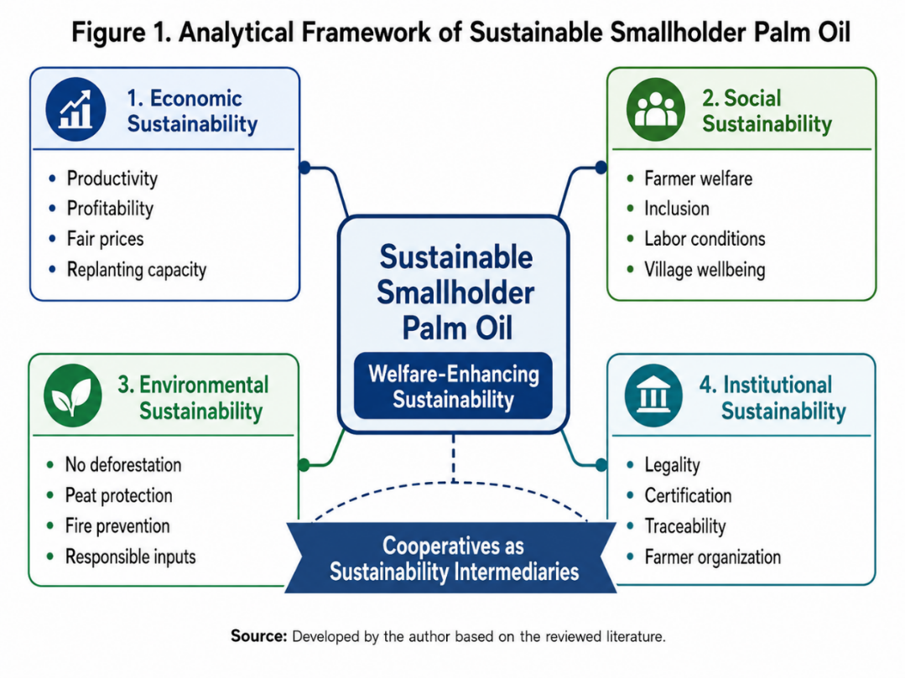

Figure 1. Analytical Framework of Sustainable Smallholder Palm Oil
Figure 1 presents the analytical framework used in this article to conceptualize sustainable smallholder palm oil as a welfare-enhancing and institutionally mediated process. The figure shows that smallholder sustainability cannot be reduced to environmental compliance alone, because it also depends on economic viability, social inclusion, and institutional capacity. Economic sustainability is represented through productivity, profitability, fair prices, and replanting capacity, while social sustainability emphasizes farmer welfare, inclusion, labor conditions, and village well-being. Environmental sustainability includes no deforestation, peat protection, fire prevention, and responsible input use. Institutional sustainability is presented as the enabling dimension that links legality, certification, traceability, and farmer organization. The figure places cooperatives as sustainability intermediaries because they can connect these four dimensions by organizing farmers, reducing transaction costs, supporting certification, strengthening market access, and ensuring that sustainability produces tangible welfare benefits for smallholder households.

Cooperatives, Collective Action, and Smallholder Inclusion
Cooperatives are rooted in collective action, which is essential when individual farmers face high transaction costs, weak bargaining power, and limited access to services (Bizikova et al., 2020; Candemir et al., 2021; Christian et al., 2024). Fragmented smallholders usually sell small volumes, lack market information, depend on intermediaries, and cannot easily negotiate with mills, banks, input suppliers, or certification bodies (Hidayat et al., 2018; Witjaksono et al., 2024). By aggregating farmers, cooperatives can create economies of scale in input procurement, output marketing, extension, certification, transport, and financial services (Christian et al., 2024; Ma & Abdulai, 2017; Mojo et al., 2017). This aggregation function is especially important in palm oil because fresh fruit bunches are perishable and must reach mills quickly after harvest (Witjaksono et al., 2024).
The performance of cooperatives depends heavily on social capital. Social capital includes trust, reciprocity, shared norms, networks, and collective identity that enable members to act together (Baka et al., 2024; Bizikova et al., 2020). Farmers are more likely to deliver produce through a cooperative, follow internal rules, disclose farm data, attend training, and accept peer monitoring when they trust cooperative leaders and perceive tangible benefits (Sellare et al., 2020; Zhu & Wang, 2024). Conversely, distrust, opaque pricing, elite capture, and weak accountability can undermine participation and make cooperatives ineffective or even harmful (Candemir et al., 2021; Christian et al., 2024). Therefore, cooperative governance is not merely an administrative matter but a core determinant of sustainability outcomes (Candemir et al., 2021).
Institutional economics provides another useful explanation for cooperative relevance. Smallholders face high transaction costs in obtaining inputs, marketing output, applying for credit, complying with legal requirements, and participating in certification schemes (Eggen et al., 2024; Meemken, 2020; Sellare et al., 2020). Cooperatives can reduce these costs by representing groups of farmers, standardizing information, maintaining records, pooling services, and negotiating with external actors (Bizikova et al., 2020; Candemir et al., 2021). In sustainability certification, cooperative characteristics matter because certified farmers are often organized and because organizational quality affects whether certification benefits are realized (Sellare et al., 2020). This implies that certification outcomes cannot be separated from the institutional quality of farmer organizations (Meemken, 2020; Sellare et al., 2020).
Value-chain governance theory also clarifies the role of cooperatives. Palm oil supply chains are characterized by unequal power relations among farmers, traders, mills, refineries, exporters, retailers, and sustainability standard-setters (Dauvergne, 2018; Ekaputri et al., 2025; Hospes, 2014; Oosterveer et al., 2014). Sustainability requirements often flow downward from buyers and regulators to producers, while benefits do not always flow back to smallholders (Eggen et al., 2024; Meemken, 2020). Cooperatives can help rebalance value-chain relations by aggregating supply, negotiating contracts, enabling traceability, and demanding that compliance requirements be matched with incentives and services (Hutabarat et al., 2019; Veriasa et al., 2024; Witjaksono et al., 2024). However, if cooperatives are captured by mills or traders, they may reproduce unequal value-chain governance rather than challenge it (Christian et al., 2024; Ekaputri et al., 2025).

METHODS
This article uses a qualitative literature review to synthesize recent scholarship on cooperatives, smallholder palm oil, sustainability certification, farmer welfare, and value-chain governance. A qualitative literature review is appropriate because the objective is not to produce a statistically exhaustive evidence map but to interpretively integrate concepts, empirical findings, and policy arguments across related fields (Snyder, 2019; Torraco, 2005). The approach differs from a systematic literature review because it does not use PRISMA procedures, bibliometric mapping, meta-analysis, or formal risk-of-bias assessment (Snyder, 2019, 2024). Instead, the review uses purposive selection and thematic synthesis to develop a policy-oriented argument about the expected roles of cooperatives in palm oil-producing villages.
Sources were identified through targeted searches in Scopus, Google Scholar, and Web of Science using combinations of the keywords "oil palm smallholder," "palm oil cooperative," "agricultural cooperative," "ISPO," "RSPO," "smallholder certification," "traceability palm oil," and "farmer welfare Indonesia," covering publications from January 2012 to mid-2025, with priority given to peer-reviewed articles published from 2020 onward. Initial searches returned approximately 180 records; after removing duplicates and screening titles and abstracts for direct relevance to Indonesian oil palm smallholders or agricultural cooperative theory, 96 sources were retained for full-text reading, of which 68 are cited directly in this article. Sources were excluded if they addressed palm oil sustainability without reference to smallholders or cooperatives, if they were not peer-reviewed or from a recognized institutional source, or if they were not available in English or Indonesian. A small number of official regulatory and statistical sources (e.g., Indonesia's Ministry of Agriculture and BPS data) were included where necessary to contextualize the national certification and land-tenure context, since the role of cooperatives in ISPO, legality, and certification cannot be understood through academic literature alone.
The literature was selected based on relevance to five themes: smallholder palm oil sustainability; agricultural cooperatives and farmer organizations; certification and sustainability standards; traceability and value-chain governance; and rural welfare and livelihoods.
The analysis followed a thematic procedure. First, the literature was read to identify recurring constraints facing smallholders, including legality gaps, certification costs, productivity problems, replanting barriers, weak market access, environmental risks, and low bargaining power. Second, the cooperative literature was reviewed to identify organizational functions that could address these constraints, including collective action, service delivery, market intermediation, financial facilitation, member governance, and digital transformation. Third, the two strands were cross-mapped and synthesized into a conceptual framework of cooperatives as sustainability intermediaries. This framework emphasizes that cooperatives should mediate between farmers and sustainability demands while ensuring that compliance generates tangible welfare benefits for smallholder households.
Because this is a purposive rather than systematic review, the selection and interpretation of sources are inherently shaped by the authors' conceptual starting point, which creates a risk of confirmation bias — that is, a tendency to select and emphasize literature that supports the article's central argument. To mitigate this risk, the review deliberately included sources that document cooperative failure, elite capture, and weak governance (e.g., Bijman & Wijers, 2019; Candemir et al., 2021; Christian et al., 2024) alongside sources documenting cooperative potential, so that the resulting framework reflects both the promise and the limitations of cooperative-based sustainability governance. Nonetheless, the findings should be read as a conceptual synthesis intended to inform policy dialogue and future empirical research, not as a validated causal or generalizable evidence base derived from primary fieldwork.

RESULTS AND DISCUSSION

The thematic synthesis identifies six expected roles of cooperatives in supporting sustainable smallholder palm oil in Indonesia. These roles are not separate functions but mutually reinforcing institutional capacities that allow cooperatives to operate as sustainability intermediaries. The six roles include democratic governance, legality and certification support, productivity and replanting services, market access and traceability, village-level sustainability coordination, and welfare-oriented services. Figure 2 summarizes these expected cooperative roles and shows how they revolve around the central function of the palm oil cooperative as a sustainability intermediary.
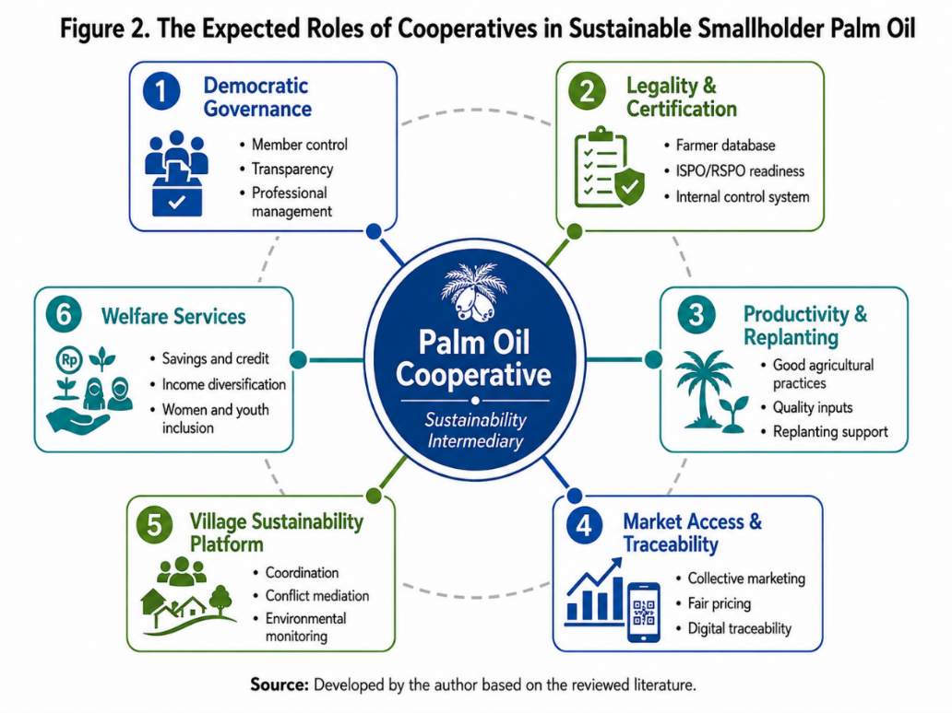
Figure 2. The Expected Roles of Cooperatives in Sustainable Smallholder Palm Oil

Figure 2 illustrates the six expected roles of cooperatives in sustainable smallholder palm oil, with the "Palm Oil Cooperative" positioned as the central institutional hub through which smallholders access services, markets, certification, finance, and sustainability support. These roles are: democratic governance (member control, transparency, professional management); legality and certification (farmer databases, ISPO/RSPO readiness, internal control systems); productivity and replanting (good agricultural practices, quality inputs, replanting support); market access and traceability (collective marketing, fair pricing, digital traceability); village sustainability platform (coordination, conflict mediation, environmental monitoring); and welfare services (savings and credit, income diversification, women and youth inclusion). Together, they define the cooperative as a multifunctional institution rather than a narrow marketing organization.
Cooperatives Should Be Democratic, Professional, and Farmer-Owned Institutions
The first thematic finding is that cooperatives capable of supporting sustainable smallholder palm oil must be democratic, professional, transparent, and genuinely farmer-owned. Democratic member control is essential because sustainability requires farmers to share information, follow agreed rules, participate in training, accept internal monitoring, and coordinate marketing decisions (Candemir et al., 2021; Zhu & Wang, 2024). If members perceive the cooperative as an elite-controlled body or a company instrument, they are unlikely to commit to certification, traceability, or collective marketing (Christian et al., 2024). Therefore, cooperative legitimacy is a precondition for sustainability implementation.
Professional management is equally important. Sustainability-oriented cooperatives must manage member databases, farm maps, legality documents, input procurement, extension schedules, fresh fruit bunch logistics, payment systems, internal audits, corrective actions, and financial reporting (Eggen et al., 2024; Witjaksono et al., 2024). These tasks exceed the capacity of informal farmer groups unless they are supported by trained managers, digital tools, clear procedures, and accountable leadership (Addison et al., 2024; Candemir et al., 2021; Indradiartha, 2025). A cooperative that is democratic but administratively weak may fail to deliver services, while a cooperative that is professional but undemocratic may become extractive or unaccountable (Christian et al., 2024).
Transparency is especially important in palm oil because price, weight, quality deduction, transport cost, and payment timing strongly affect farmers' trust. Cooperatives should disclose fresh fruit bunch prices, cooperative margins, mill payments, transport charges, certification premiums, input procurement costs, and loan terms to members (Hutabarat et al., 2019; Veriasa et al., 2024; Witjaksono et al., 2024). Transparent governance can reduce suspicion, increase member loyalty, and strengthen collective marketing. In this sense, cooperative accountability is not separate from economic performance; it directly affects whether farmers use cooperative services.
However, democratic structure on paper does not automatically guarantee inclusive outcomes in practice. A cooperative can remain formally member-governed while decision-making is effectively concentrated among a small group of better-resourced or better-connected members. This suggests that democratic design must be paired with active inclusion safeguards, not assumed as a natural outcome of cooperative legal status.

Cooperatives Should Serve as Legality and Certification Hubs
The second thematic finding is that cooperatives should become legality and certification hubs for smallholders. Many farmers face barriers to certification because they lack land certificates, plantation registration, clear plot boundaries, historical land-use records, or formal farm documentation (Hidayat et al., 2018; Hutabarat et al., 2019; Jelsma et al., 2017; Veriasa et al., 2024). Individual farmers often cannot navigate these requirements alone because the process involves village authorities, district plantation offices, land agencies, forest-zone maps, certification bodies, and sometimes company records (Eggen et al., 2024). Cooperatives can reduce these barriers by coordinating document collection, farm mapping, farmer registration, legality verification, and communication with the local government.
Certification systems require internal control systems that are difficult for individual farmers but feasible for organized groups. A cooperative-based internal control system can maintain member lists, training records, farm inspection forms, non-compliance reports, corrective-action plans, harvest records, and audit preparation documents (Eggen et al., 2024; Hutabarat et al., 2019; Veriasa et al., 2024). Such systems are essential for group certification because external auditors need evidence that members are monitored and that sustainability requirements are implemented consistently. Cooperatives can also reduce certification costs by spreading expenses across members and coordinating support from mills, government programs, or development partners (Eggen et al., 2024).
Cooperatives should also translate certification language into practical farmer guidance. Standards often use technical and legal language that farmers may find difficult to interpret (Hidayat et al., 2018; Meemken, 2020). Cooperatives can convert abstract principles into practical rules on no burning, protected areas, chemical use, riparian management, labor practices, harvesting, recordkeeping, and grievance procedures (Hutabarat et al., 2019; Jelsma et al., 2017; Veriasa et al., 2024). This translation function is crucial because sustainability compliance depends not only on awareness but also on farmers' ability to apply rules in everyday farm management.
At the same time, cooperative-based certification does not by itself guarantee equitable access. Farmers who are not affiliated with any cooperative, or who belong to weakly organized ones, may remain excluded from certified supply chains even where group certification mechanisms exist elsewhere in the system. This indicates that the legality-and-certification-hub role is a necessary but not sufficient condition for inclusive certification.
Cooperatives Should Strengthen Productivity, Good Agricultural Practices, and Replanting
The third thematic finding is that cooperatives should support productivity improvement and replanting because welfare-enhancing sustainability requires higher yields on existing land. Low productivity undermines smallholder income and may indirectly increase pressure for land expansion (Li, 2024; Monzon et al., 2021; Woittiez et al., 2017). Good agricultural practices can improve yields through better seedlings, appropriate fertilization, harvesting discipline, pruning, pest management, soil conservation, and farm recordkeeping (Suardi et al., 2022; Woittiez et al., 2017). Cooperatives can support adoption by organizing training, demonstration plots, peer learning, and technical assistance.
Input procurement is a concrete cooperative service. Many smallholders buy fertilizer, herbicides, and seedlings individually at uncertain prices and quality (Witjaksono et al., 2024). Cooperatives can purchase inputs collectively, verify quality, negotiate discounts, and distribute inputs transparently to members. This function can increase profitability by reducing input costs and improving input effectiveness. It can also support environmental sustainability if input use is linked to training and recordkeeping.
Replanting is one of the most important long-term challenges for smallholder sustainability. Aging palms reduce productivity and income, but replanting requires capital, quality seedlings, technical knowledge, and household income support during the immature period (Suardi et al., 2022; Woittiez et al., 2017). Cooperatives can coordinate replanting applications, organize eligible members, negotiate finance, manage nurseries, supervise contractors, and connect farmers with temporary livelihood support (Witjaksono et al., 2024). Cooperative-led replanting can also reduce the risk that farmers expand into new land rather than rehabilitate old plantations (Li, 2024).

Cooperatives Should Build Fair and Traceable Market Access
The fourth thematic finding is that cooperatives should create fair and traceable market access. Smallholders often sell fresh fruit bunches through traders because traders provide transport, cash, and convenience, but this may reduce price transparency and bargaining power (Hidayat et al., 2018; Witjaksono et al., 2024). Cooperatives can aggregate fresh fruit bunches, negotiate directly with mills, reduce intermediary margins, and improve price transparency. However, collective marketing will only work if cooperatives offer reliable weighing, fast payment, efficient transport, and clear communication with members.
Traceability is increasingly central to sustainable palm oil governance because buyers, regulators, and certification systems require information about where fruit originates and whether it is linked to deforestation or illegality (Dauvergne, 2018; Ekaputri et al., 2025; Irawan et al., 2024; Oosterveer et al., 2014). Cooperatives can record transactions by member and plot, link harvest data to geolocation, monitor delivery to mills, and provide traceability reports. Digital tools can help, but digital traceability requires accurate data, farmer consent, training, infrastructure, and trust (Addison et al., 2024; Eggen et al., 2024; Indradiartha, 2025; Irawan et al., 2024). Technology without institutional legitimacy may create surveillance concerns or administrative burdens rather than inclusion.
Fair market access requires that traceability and certification generate tangible benefits. If farmers provide data, change practices, and pay compliance costs without receiving better prices, stable contracts, technical support, or improved services, they may perceive sustainability as an external burden (Eggen et al., 2024; Meemken, 2020; Sellare et al., 2020). Cooperatives should therefore negotiate with mills and buyers for benefit-sharing mechanisms, including premiums, long-term purchase contracts, input support, transport support, extension funding, and cooperative sustainability funds (Ekaputri et al., 2025; Hutabarat et al., 2019; Veriasa et al., 2024). Sustainability should not be a one-way demand imposed on farmers; it should be a reciprocal arrangement that rewards compliance and strengthens livelihoods.
This benefit-sharing expectation should be treated as a policy goal rather than an established outcome. In practice, certification premiums and traceability investments do not always reach smallholders in full, even when farmers participate through an organized cooperative.

Cooperatives Should Become Village-Level Sustainability Platforms
The fifth thematic finding is that cooperatives should operate as village-level sustainability platforms. Palm oil sustainability is not only a farm-level issue because land-use planning, fire prevention, road maintenance, drainage management, conflict mediation, and environmental monitoring require coordination across farmers and institutions (Gaveau et al., 2022; Li, 2024; Purnomo et al., 2020). Cooperatives can provide a practical platform for coordinating farmers with village governments, customary leaders, mills, district agencies, extension providers, and civil society organizations. This platform role is especially important where smallholder plots are interspersed with forests, peatlands, riparian zones, settlements, and other land uses.
Village governments can support cooperative-based sustainability through farmer data verification, land-use deliberation, infrastructure planning, conflict mediation, and integration with village development plans. However, cooperatives should remain member-owned and should not become political instruments of village elites (Candemir et al., 2021; Christian et al., 2024). The best arrangement is complementary: village government provides public authority and planning support, while cooperatives provide farmer organization and economic services. This can create a local governance ecosystem where sustainability is embedded in village development rather than treated as an external certification project.
Environmental stewardship should be incorporated into cooperative rules and member agreements. Cooperatives can establish internal commitments on no burning, no new planting in protected areas, riparian protection, chemical safety, waste management, and reporting of environmental risks (Hutabarat et al., 2019; Jelsma et al., 2017; Veriasa et al., 2024). Cooperatives can also organize peer monitoring and collective action for fire prevention, especially in vulnerable landscapes. Such mechanisms are more likely to work when members understand the economic and social value of environmental protection.

Cooperatives Should Improve Welfare Beyond Fresh Fruit Bunch Sales
The sixth thematic finding is that cooperatives should improve welfare beyond commodity sales. Smallholder welfare depends not only on fresh fruit bunch prices but also on household resilience, debt management, health, education, savings, income diversification, and social protection (Cramb & Curry, 2012; Judijanto, 2025; Li, 2024; Santika et al., 2019; Sukiyono et al., 2022). Cooperatives can provide savings and credit services, emergency funds, replanting transition support, household financial literacy, and access to government welfare programs. These functions can reduce vulnerability during price downturns, crop failure, illness, or replanting periods.
Income diversification is important because oil palm households face price volatility, pest risks, climate risks, and income gaps during replanting (Euler et al., 2017; Li, 2024). Cooperatives can support intercropping during replanting, livestock, food crops, local processing, women-led enterprises, or service businesses linked to the palm oil economy. Diversification should not be understood as abandoning palm oil but as strengthening household resilience and reducing dependence on a single commodity.
Women and youth inclusion should also become cooperative priorities. Palm oil institutions are often male-dominated, even though women contribute to household finance, farm labor, social reproduction, and community welfare (Bizikova et al., 2020; Cramb & Curry, 2012; Judijanto, 2025; Santika et al., 2019). Youth participation is important because younger farmers may be more capable of adopting digital traceability, farm records, and modern agronomic practices (Addison et al., 2024; Bijman & Wijers, 2019; Indradiartha, 2025). Cooperatives that include women and youth can become more adaptive and socially legitimate.

DISCUSSION AND ANALYSIS

Cooperatives as Sustainability Intermediaries
The findings suggest that cooperatives should be conceptualized as sustainability intermediaries. This means that cooperatives mediate between smallholders and the sustainability demands generated by governments, certification bodies, buyers, mills, civil society, and international markets (Dauvergne, 2018; Eggen et al., 2024; Hospes, 2014; Oosterveer et al., 2014). Their intermediary role includes translating standards, organizing data, reducing costs, providing services, negotiating benefits, and ensuring that compliance is socially embedded. Without such intermediaries, sustainability requirements may privilege already-organized farmers and exclude independent smallholders who lack documentation and institutional support (Ekaputri et al., 2025; Meemken, 2020).
This intermediary role must be democratic and accountable. Cooperatives that control member data, certification premiums, market channels, and internal audits hold significant power over farmers (Candemir et al., 2021; Christian et al., 2024). If this power is not governed transparently, sustainability intermediation may generate new forms of dependency. Therefore, cooperatives must combine technical competence with member control, financial transparency, grievance mechanisms, and regular leadership accountability.

From Administrative Cooperatives to Transformative Cooperatives
The article distinguishes between administrative cooperatives and transformative cooperatives. Administrative cooperatives exist mainly to meet legal or project requirements, channel assistance, or provide a formal identity for farmer groups. Transformative cooperatives actively improve member welfare, strengthen bargaining power, deliver services, and manage sustainability compliance (Candemir et al., 2021; Christian et al., 2024). In the palm oil sector, transformative cooperatives should maintain farmer databases, support legality, prepare certification, coordinate extension, organize replanting, aggregate marketing, operate traceability, and negotiate benefits with mills and buyers.
Transformative cooperatives require investment. They cannot be expected to manage certification, traceability, replanting, and welfare services without trained staff, working capital, digital infrastructure, management systems, and external support (Eggen et al., 2024; Witjaksono et al., 2024). Government agencies, mills, financial institutions, and development partners should therefore treat cooperatives as rural sustainability infrastructure. This framing shifts cooperative support from short-term project assistance to long-term institutional development.

Integrating Sustainability and Welfare
A key implication of this review is that sustainability must be welfare-enhancing. Farmers are more likely to support sustainability when it improves income, reduces risk, strengthens market access, secures legality, lowers input costs, and creates future livelihood security (Cramb & Curry, 2012; Judijanto, 2025; Li, 2024; Santika et al., 2019; Sellare et al., 2020). Conversely, farmers may resist or ignore sustainability requirements if these are experienced as costly audits, paperwork, restrictions, or surveillance without meaningful benefits (Eggen et al., 2024; Meemken, 2020). Therefore, cooperative-led sustainability should connect compliance with practical improvements in everyday farming and household life.
This does not mean weakening environmental standards. Instead, it means implementing environmental standards through socially just mechanisms. Zero-deforestation requirements should be paired with support for intensification, replanting, legal clarification, livelihood diversification, and fair market access (Gaveau et al., 2022; Li, 2024). Certification should be paired with cost-sharing, training, internal control support, and benefit-sharing. Traceability should be paired with data rights, farmer incentives, and transparent use of information. Cooperatives can help ensure that sustainability is not merely imposed on smallholders but co-produced with them.
The practical relationship among smallholder challenges, cooperative responses, and expected sustainability outcomes is presented in Figure 3.

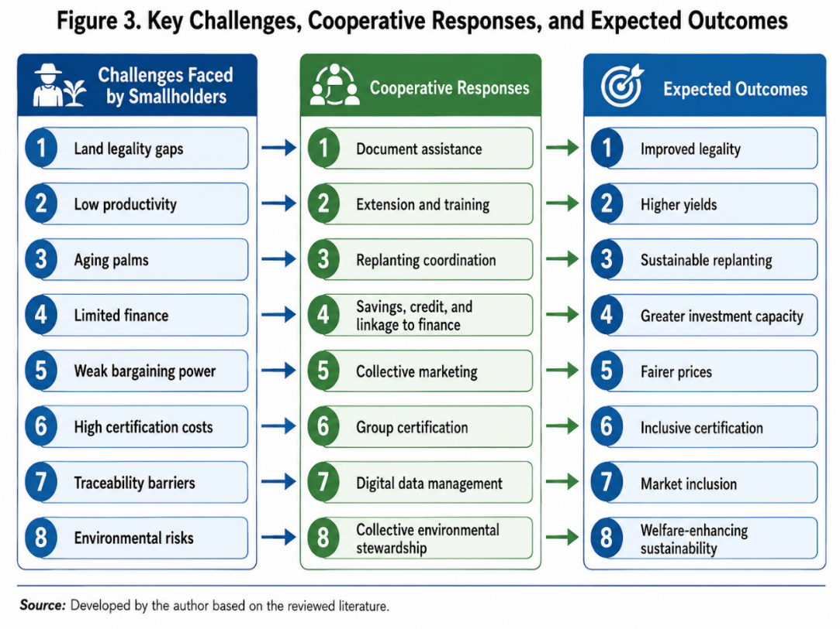
Figure 3. Key Challenges, Cooperative Responses, and Excpected Outcomes

Figure 3 translates the article's argument into a problem-response-outcome structure: smallholder challenges (e.g., legality gaps, low productivity, aging palms, limited finance, weak bargaining power, high certification costs, traceability barriers, environmental risks) are matched with cooperative responses (document assistance, extension and training, replanting coordination, savings and credit, collective marketing, group certification, digital data management, collective environmental stewardship) and their expected outcomes (improved legality, higher yields, sustainable replanting, greater investment capacity, fairer prices, inclusive certification, market inclusion, welfare-enhancing sustainability). It is the authors' conceptual synthesis, not derived from a specific empirical dataset.

Policy Recommendations
The following recommendations follow from the thematic findings and conceptual synthesis above but should be read as policy propositions requiring empirical testing and context-specific adaptation, not as validated interventions.
First, Indonesia should prioritize cooperative capacity building as a core element of smallholder palm oil sustainability policy. This includes training cooperative managers, strengthening financial reporting, developing internal control systems, supporting member education, and professionalizing cooperative service delivery. Cooperative development should be treated as a precondition for inclusive ISPO implementation rather than as a secondary rural development activity.
Second, certification costs should be shared across the government, mills, buyers, and development finance institutions. Smallholders should not be expected to bear the full cost of mapping, documentation, training, auditing, and corrective action because these costs serve public environmental goals and supply-chain market access (Eggen et al., 2024; Meemken, 2020). Cooperative-based group certification should be prioritized because it can reduce per-farmer costs and strengthen collective learning.
Third, cooperatives should be integrated into land legality and farmer database programs. District governments, land agencies, village governments, and plantation offices should work with cooperatives to verify farmer identities, map plots, resolve administrative gaps, and support plantation registration. Without legal support, certification and traceability will remain inaccessible to many smallholders.
Fourth, cooperative-led replanting should be expanded. Replanting support should combine finance, certified seedlings, technical assistance, temporary income support, and market linkage. Cooperatives can organize eligible farmers, reduce transaction costs for lenders, and supervise implementation. Replanting should be framed as both a productivity strategy and a deforestation-prevention strategy.
Fifth, mills and buyers should be required or incentivized to build fair partnerships with smallholder cooperatives. These partnerships should include transparent pricing, stable purchase arrangements, traceability support, certification cost-sharing, and technical assistance. A supply chain that demands sustainability from farmers but does not share costs or benefits is unlikely to be inclusive.
Sixth, digital traceability systems should be cooperative-based and farmer-centered. Digital systems should be designed around farmer consent, data protection, usability, offline functionality where needed, and clear benefits for members. Data should not become a mechanism for excluding vulnerable farmers without remediation support.
Seventh, cooperatives should broaden their welfare functions. Savings and credit, emergency funds, household financial literacy, women's enterprise support, youth training, and income diversification can make sustainability more resilient and socially meaningful. A cooperative that improves household welfare is more likely to sustain member participation than a cooperative that only collects data for certification.
The institutional and policy architecture required to strengthen cooperative-based palm oil sustainability is summarized in Figure 4.
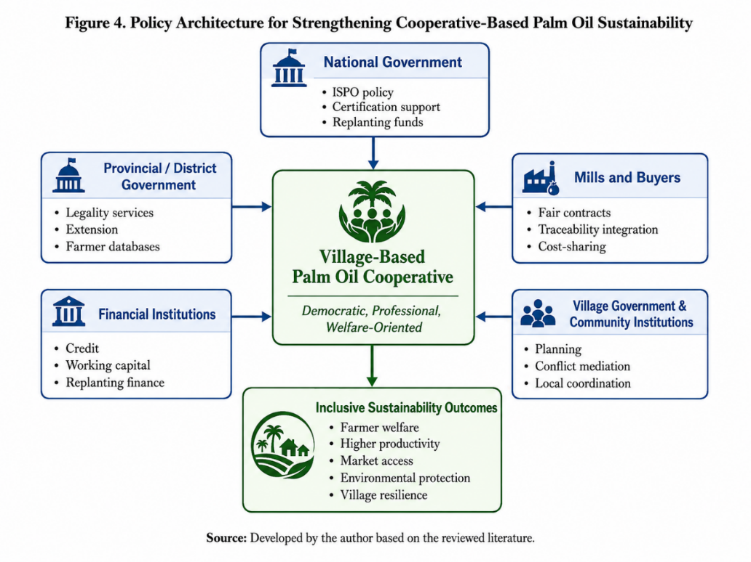
Figure 4. Policy Architecture for Strengthening Cooperative-Based Palm Oil Sustainability

Figure 4 presents the policy architecture needed to strengthen cooperative-based palm oil sustainability, placing the village-based palm oil cooperative at the center as the institution closest to smallholders and capable of integrating legality support, certification readiness, market access, replanting services, and welfare functions. Surrounding actors national, provincial, and district government; mills and buyers; financial institutions; and village governments and community institutions form the institutional ecosystem needed to make the cooperative effective, ultimately producing farmer welfare, higher productivity, market access, environmental protection, and village resilience. It is the authors' conceptual synthesis, not derived from a specific empirical dataset

CONCLUSIONS
This qualitative literature review argues that cooperatives should play a central role in supporting sustainable smallholder palm oil in Indonesia. Smallholders are indispensable to the palm oil economy and to sustainability outcomes, but they face institutional barriers that cannot be solved individually. Land legality, certification, traceability, productivity improvement, replanting, market access, and environmental stewardship all require collective organization.
The article has argued that the cooperative needed in palm oil-producing villages is not merely a conventional marketing body. It should be a democratic, professional, transparent, and welfare-oriented sustainability intermediary. Its expected roles include legality assistance, certification preparation, internal control systems, agronomic extension, input procurement, replanting coordination, collective marketing, digital traceability, environmental monitoring, conflict mediation, and welfare services.
The article also emphasizes that cooperatives are not automatically effective. Weak governance, elite capture, low trust, limited managerial capacity, and unequal market relations can undermine cooperative performance. Therefore, cooperative strengthening must be treated as a strategic policy agenda. Government should finance cooperative capacity building, support certification and traceability costs, integrate cooperatives into ISPO implementation, and facilitate fair partnerships with mills. Companies and buyers should support cooperatives through transparent contracts, technical assistance, and benefit-sharing. Financial institutions should design cooperative-based credit for replanting, input procurement, and sustainability upgrading.
The main conclusion is that sustainable smallholder palm oil requires a shift from compliance-centered governance to welfare-enhancing sustainability. Cooperatives can become the institutional bridge between farmers, villages, markets, and sustainability standards. If built democratically and professionally, they can help Indonesia pursue palm oil sustainability without sacrificing the welfare, dignity, and inclusion of small farmers.

REFERENCE
Addison, M. et al. (2024). Exploring the impact of agricultural digitalization on smallholder farmers' livelihoods in Ghana. Heliyon, 10(6), e27541. https://doi.org/10.1016/j.heliyon.2024.e27541
Austin, K. G., Schwantes, A., Gu, Y., & Kasibhatla, P. S. (2019). What causes deforestation in Indonesia? Environmental Research Letters, 14(2), 024007. https://doi.org/10.1088/1748-9326/aaf6db
Baka, W. K., Rianse, U. S., & la Zulfikar, Z. (2024). Palm oil business partnership sustainability through the role of social capital and local wisdom: Evidence from palm oil plantations in Indonesia. Sustainability, 16(17), 7541. https://doi.org/10.3390/su16177541
Bijman, J., & Wijers, G. (2019). Exploring the inclusiveness of producer cooperatives. Current Opinion in Environmental Sustainability, 41, 74–79. https://doi.org/10.1016/j.cosust.2019.11.005
Bizikova, L. et al. (2020). A scoping review of the contributions of farmers' organizations to smallholder agriculture. Nature Food, 1(10), 620–630. https://doi.org/10.1038/s43016-020-00164-x
Candemir, A., Duvaleix, S., & Latruffe, L. (2021). Agricultural cooperatives and farm sustainability—A literature review. Journal of Economic Surveys, 35(4), 1118–1144. https://doi.org/10.1111/joes.12395
Christian, M., Obi, A., Zantsi, S., Mdoda, L., & Jiba, P. (2024). The role of cooperatives in improving smallholder participation in agri-food value chains: A case study of one local municipality in Eastern Cape, South Africa. Sustainability, 16(6), 2241. https://doi.org/10.3390/su16062241
Cramb, R., & Curry, G. N. (2012). Oil palm and rural livelihoods in the Asia–Pacific region: An overview. Asia Pacific Viewpoint, 53(3), 223–239. https://doi.org/10.1111/j.1467-8373.2012.01495.x
Dauvergne, P. (2018). The global politics of the business of "sustainable" palm oil. Global Environmental Politics, 18(2), 34–52. https://doi.org/10.1162/glep_a_00455
Descals, A., Wich, S., Meijaard, E., Gaveau, D. L. A., Peedell, S., & Szantoi, Z. (2021). High-resolution global map of smallholder and industrial closed-canopy oil palm plantations. Earth System Science Data, 13(3), 1211–1231. https://doi.org/10.5194/essd-13-1211-2021
Eggen, M. et al. (2024). Smallholder participation in zero-deforestation supply chain initiatives in the Indonesian palm oil sector: Challenges, opportunities, and limitations. Elementa: Science of the Anthropocene, 12(1). https://doi.org/10.1525/elementa.2023.00099
Ekaputri, A. D., Gaveau, D. L. A., Heilmayr, R., & Carlson, K. M. (2025). Uneven participation of independent and contract smallholders in certified palm oil mill markets in Indonesia. Communications Earth & Environment, 6(1), 721. https://doi.org/10.1038/s43247-025-02683-6
Euler, M., Krishna, V. V., Schwarze, S., Siregar, H., & Qaim, M. (2017). Oil palm adoption, household welfare, and nutrition among smallholder farmers in Indonesia. World Development, 93, 219–235. https://doi.org/10.1016/j.worlddev.2016.12.019
Gatto, M., Wollni, M., Asnawi, R., & Qaim, M. (2017). Oil palm boom, contract farming, and rural economic development: Village-level evidence from Indonesia. World Development, 95, 127–140. https://doi.org/10.1016/j.worlddev.2017.02.010
Gaveau, D. L. A. et al. (2022). Slowing deforestation in Indonesia follows declining oil palm expansion and lower oil prices. PLoS ONE, 17(3), e0266178. https://doi.org/10.1371/journal.pone.0266178
Hidayat, N. K., Glasbergen, P., & Offermans, A. (2018). Sustainability certification and palm oil smallholders' livelihood: A comparison between RSPO and ISPO standards. Journal of Rural Studies, 65, 245–254. https://doi.org/10.1016/j.jrurstud.2018.03.013
Hospes, O. (2014). Marking the success or end of global multi-stakeholder governance? The rise of national sustainability standards in Indonesia and Brazil for palm oil and soy. Agriculture and Human Values, 31(3), 425–437. https://doi.org/10.1007/s10460-014-9511-9
Hutabarat, S., Slingerland, M., & Dries, L. (2019). Explaining the "certification gap" for different types of oil palm smallholders in Riau Province, Indonesia. The Journal of Environment & Development, 28(3), 253–281. https://doi.org/10.1177/1070496519854505
Indradiartha, R. J. A. (2025). Digital transformation of agricultural cooperatives: Service innovation and its impact on millenial farmers' income in East Java. IJEBAS: International Journal of Economics, Business, Accounting, Agriculture Management and Sharia Administration, 5(4), 1707–1713. https://doi.org/10.54443/ijebas.v5i4.3828
Irawan, S. et al. (2024). Cost reduction for upscaling voluntary sustainability standards: The case of independent oil palm smallholders in Central Kalimantan, Indonesia. Frontiers in Forests and Global Change, 7, 1418782. https://doi.org/10.3389/ffgc.2024.1418782
Jelsma, I., Schoneveld, G. C., Zoomers, A., & van Westen, A. C. M. (2017). Unpacking Indonesia's independent oil palm smallholders: An actor-disaggregated approach to identifying environmental and social performance challenges. Land Use Policy, 69, 281–297. https://doi.org/10.1016/j.landusepol.2017.08.012
Judijanto, L. (2025). Balancing development and conservation: The role of oil palm in achieving prosperity and sustainable rural livelihoods. Financ a Úvěr-Czech Journal of Economics and Finance, 75(1). https://doi.org/10.32065/vol75n1a65
Li, T. M. (2024). Securing oil palm smallholder livelihoods without more deforestation in Indonesia. Nature Sustainability, 7(4), 387–393. https://doi.org/10.1038/s41893-024-01279-w
Ma, W., & Abdulai, A. (2017). The economic impacts of agricultural cooperatives on smallholder farmers in rural China. Agribusiness, 33(4), 537–551. https://doi.org/10.1002/agr.21522
Meemken, E. M. (2020). Do smallholder farmers benefit from sustainability standards? A systematic review and meta-analysis. Global Food Security, 26, 100373. https://doi.org/10.1016/j.gfs.2020.100373
Mojo, D., Fischer, C., & Degefa, T. (2017). The determinants and economic impacts of membership in coffee farmer cooperatives: Recent evidence from rural Ethiopia. Journal of Rural Studies, 50, 84–94. https://doi.org/10.1016/j.jrurstud.2016.12.010
Monzon, J. P. et al. (2021). Fostering a climate-smart intensification for oil palm. Nature Sustainability, 4(7), 595–601. https://doi.org/10.1038/s41893-021-00700-y
Oosterveer, P., Adjei, B. E., Vellema, S., & Slingerland, M. (2014). Global sustainability standards and food security: Exploring unintended effects of voluntary certification in palm oil. Global Food Security, 3(3–4), 220–226. https://doi.org/10.1016/j.gfs.2014.09.006
Pacheco, P., Schoneveld, G., Dermawan, A., Komarudin, H., & Djama, M. (2020). Governing sustainable palm oil supply: Disconnects, complementarities, and antagonisms between state regulations and private standards. Regulation & Governance, 14(3), 568–598. https://doi.org/10.1111/rego.12220
Purnomo, H. et al. (2020). Reconciling oil palm economic development and environmental conservation in Indonesia: A value chain dynamic approach. Forest Policy and Economics, 111, 102089. https://doi.org/10.1016/j.forpol.2020.102089
Santika, T. et al. (2019). Does oil palm agriculture help alleviate poverty? A multidimensional counterfactual assessment of oil palm development in Indonesia. World Development, 120, 105–117. https://doi.org/10.1016/j.worlddev.2019.04.012
Sellare, J., Meemken, E., Kouamé, C., & Qaim, M. (2020). Do sustainability standards benefit smallholder farmers also when accounting for cooperative effects? Evidence from Côte d'Ivoire. American Journal of Agricultural Economics, 102(2), 681–695. https://doi.org/10.1002/ajae.12015
Snyder, H. (2019). Literature review as a research methodology: An overview and guidelines. Journal of Business Research, 104, 333–339. https://doi.org/10.1016/j.jbusres.2019.07.039
Snyder, H. (2024). Designing the literature review for a strong contribution. Journal of Decision Systems, 33(4), 551–558. https://doi.org/10.1080/12460125.2023.2197704
Suardi, T. F., Sulistyowati, L., Noor, T. I., & Setiawan, I. (2022). Analysis of the sustainability level of smallholder oil palm agribusiness in Labuhanbatu Regency, North Sumatra. Agriculture, 12(9), 1469. https://doi.org/10.3390/agriculture12091469
Suhardjo, I., & Suparman, M. (2025). Harmonizing sustainability certification standards: The Indonesian palm oil case. International Food and Agribusiness Management Review, 28(1), 19–34. https://doi.org/10.22434/ifamr.1218
Sukiyono, K. et al. (2022). The contribution of oil palm smallholders farms to the implementation of the sustainable development goals-measurement attempt. Sustainability, 14(11), 6843. https://doi.org/10.3390/su14116843
Supriatna, J., Djumarno, D., Saluy, A. B., & Kurniawan, D. (2024). Sustainability analysis of smallholder oil palm plantations in several provinces in Indonesia. Sustainability, 16(11), 4383. https://doi.org/10.3390/su16114383
Torraco, R. J. (2005). Writing integrative literature reviews: Guidelines and examples. Human Resource Development Review, 4(3), 356–367. https://doi.org/10.1177/1534484305278283
Veriasa, T. O., Nurrunisa, M., & Fadhli, N. (2024). Revisiting the implications of RSPO smallholder certification relative to farm productivity in Riau, Indonesia. Forest and Society, 8(1), 123–139. https://doi.org/10.24259/fs.v8i1.26964
Witjaksono, J. et al. (2024). Corporate farming model for sustainable supply chain crude palm oil of independent smallholder farmers. Frontiers in Sustainable Food Systems, 8. https://doi.org/10.3389/fsufs.2024.1418732
Woittiez, L. S., van Wijk, M. T., Slingerland, M., van Noordwijk, M., & Giller, K. E. (2017). Yield gaps in oil palm: A quantitative review of contributing factors. European Journal of Agronomy, 83, 57–77. https://doi.org/10.1016/j.eja.2016.11.002
Zhu, X., & Wang, G. (2024). Impact of agricultural cooperatives on farmers' collective action: A study based on the socio-ecological system framework. Agriculture, 14(1), 96. https://doi.org/10.3390/agriculture14010096

